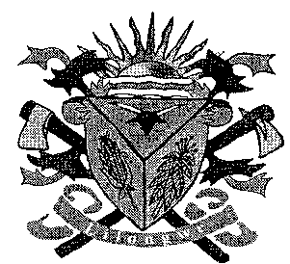**THE LILONGWE URBAN DISTRICT EXAMINATION BOARD**

**2023 END OF THIRD TERM EXAMINATIONS FOR STD 7**

**MATHEMATICS**

**(100 Marks)**

**Time allowed: ……………**

**Date: ……./…../…….**

**NAME OF CANDIDATE: ________________________________________________________________**

**(Surname first)**

**NAME OF SCHOOL: ___________________________________________________________________**

**INSTRUCTIONS**

* This paper contains **6 pages**. Please check
* Answer all questions in all sections
* This paper has **two** sections **A** **and B**
* Encircle the letter corresponding to the right answer to each question
* Follow instructions for each section carefully.
* In the table provided on this page, **tick** against the question number you have answered

**IMPORTANT**

* Make sure you have written your **name** and **school name** on the question paper in the spaces provided.
* Please hand in your filled-in question paper to the invigilator at the end of the examination

|  |  |  |  |
| --- | --- | --- | --- |
| **Question number** | **Tick question if answered** | **Do not write in these columns** | |
| 1- 20 |  |  |  |
| 21 |  |  |  |
| 22 |  |  |  |
| 23 |  |  |  |
| 24 |  |  |  |
| 25 |  |  |  |
| 26 |  |  |  |
| 27 |  |  |  |
| 28 |  |  |  |
| 29 |  |  |  |
| 30 |  |  |  |
|  | |  |  |
|  |  |

**SECTION A**

1. Express nineteen in Roman Numerals
   1. XV C. XIX
   2. XXI D. XVII
2. What is the average of 18, 24, 28 and 46
   1. 11 C. 18
   2. 29 D. 36
3. Simplify 8 -2
   1. C. 6
   2. D. 5
4. Express 80% as a fraction
   1. C.
   2. D.
5. Express 32000cm3 in litres

a. 320ℓ C. 3200

* 1. 32litres D. 320

1. What is the simplest form of the following ratios 42: 96?

A. 7:16 C. 6:7

* 1. 7:17 D. 6.17

1. Express 395.4876 to 2 significant figures
   1. 390 C. 395.48
   2. 400 D. 395.49
2. Express 9 a decimal. Write your answer to 2 decimal places
   1. 0.007 C. 9.07
   2. 9.01 D. 9.067
3. Calculate the area of a circle below

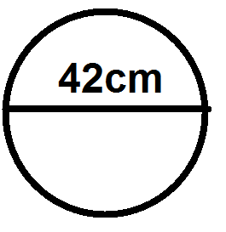

* 1. 1386cm2 C. 2386cm2
  2. 2772cm2 D.

1. Find the sum of 33, 0.11 and 2.4
   1. 68 C. 3551
   2. 332.51 D. 35.51
2. 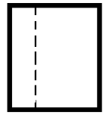Which of the following shapes show line of symmetry

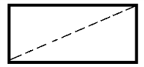

* 1. C.

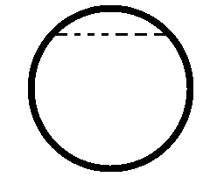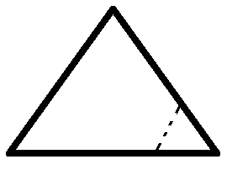

* 1. D.

1. A piece of cloth 96m 40cm is equally shared among 8 people. What is the length of each piece
   1. 13m 5cm C. 15m 15cm
   2. 12m 5cm D. 10m 7cm
2. Write 10:20pm in 24hours
   1. 22:45am C. 22: 20pm
   2. 22:30pm D. 22:25am
3. The figure below shows the type of an angle.

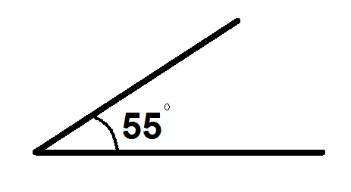

What name is given to the type of angle?

* 1. Acute angle C. Obtuse angle
  2. Reflex angle D. Right angle

1. Find the simple interest on K600.00 for 2 years at 2% per annum
   1. K12.00 C. K14.00
   2. K240.00 D. K24.00
2. How many decades are there in 5 human’s generations?
   1. 5 C. 15
   2. 50 D. 150
3. Write down the rule from the following patterns

144, 72, 36, 18

* 1. Subtract 2 C. Divide by 2
  2. Add 2 D. Multiply by 2

1. Express 2 as a percentage
   1. 234% C. 11%
   2. 225% D. 275%
2. Simplify 25n – 15n – 5n
   1. 5n C. 25n
   2. 15n D. 10n
3. The volume of a water tank is 60m3. If the tank is 5m long and 3m high, find its width
   1. 3m C. 4m
   2. 6m D. 5m

**SECTION B (60MARKS)**

1. (a) Express 3175.689 to the nearest tenth
2. Tenth

1mark

1. Whole number

1mark

(b) The average of three bags of groundnuts is 124kg. If two of them have masses of 130kg and 180kg

Respectively. Find the mass of the 3rd bag

5marks

1. (a) Mphatso thinks of a number x and decreases it by 8, the result is 6 find the number

(b) Kg gm

553 307

× 9

5marks

1. Find the bill of the following budget

7 loaves of bread at K80.00 each

3kgs sugar at K95.00 per kg

13 packets of salt at K18.00 each

4 litres cooking oil at K186.00 per litre

6marks

**Figure below is a plan of building made up of a semi – circle XYZ and a rectangle XSTZ with a length equal to 28m and width 10m. Use it to answer question 24a**

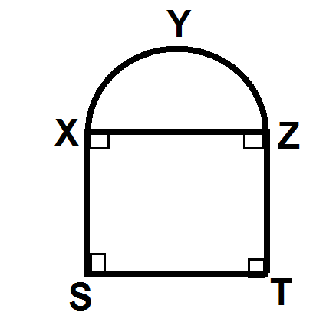

1. (a) What is the perimeter of the plan of the building

4marks

(b) Find the total area of the plan of the building

4marks

1. (a) Find the HCF of 56 and 64 using continued division method

3marks

(b) Simplify : 2

3marks

1. Use the table below to answer questions 26a and b

|  |  |
| --- | --- |
| **Value of postal orders** | **Commission** |
| K50.00 | K5.00 |
| K100.00 | K10.00 |
| K200.00 | K20.00 |
| K500.00 | K50.00 |
| K10 000.00 | K100.00 |

1. John bought 2 postal orders valued at K500 each. How much commission did he pay for the postal orders?

2marks

1. What would be the value of a postal order whose commission is K100.00?

1mark

1. Simplify

4marks

1. Temwa sold 5 bottles of cooking oil at K45, 000 each and sold them at K 36, 000.00 each. Find profit he made

3marks

1. Chikondi started a sugarcane business on July 1, 2008 with a capital of K600. She bought and sold sugarcane as shown below

3/07/08 bought sugarcane K570

5/07/08 sold sugarcane K450

9/07/08 sold sugarcane K150

12/07/08 sold sugarcane K500

13/07/08 bought sugarcane K600

17/ 07/08 sold sugarcane K400

Prepare and balance a cash account for her business

10marks

1. Jane collected information on number of eggs she collected from her poultry farm

Monday 1:50 eggs

Tuesday 2:35 eggs

Wednesday 3:10 eggs

Thursday 4:35eggs

Friday 5:20 eggs

Draw a picture graph using a scale of egg representing 10 eggs

7marks

**END OF QUESTION PAPER**