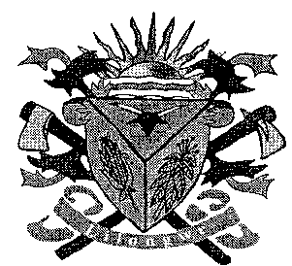**THE LILONGWE URBAN DISTRICT EXAMINATION BOARD**

**2023 END OF THIRD TERM EXAMINATIONS FOR STD 5**

**EXPRESSIVE ARTS**

**(100 Marks)**

**Time allowed: ……………**

**Date: ……./…../…….**

**NAME OF CANDIDATE: ________________________________________________________________**

**(Surname first)**

**NAME OF SCHOOL: ___________________________________________________________________**

**INSTRUCTIONS**

* This paper contains **5 pages**. Please check

Answer **all** questions.

* This paper has **two** sections **A**  **and B.**
* Follow instructions for each section carefully.

**IMPORTANT**

* Make sure you have written your **name** and **school name** on the question paper in the spaces provided.
* Please hand in your filled-in question paper to the invigilator at the end of the examination

**SECTION A**

**EXPRESSIVE ARTS (10MARKS)**

1. Which of the following is the basic skill of netball
   1. Heading C. Shooting
   2. Passing D. Serving
2. Which of the following uses verbal communication
   1. Gestures C. Drawing
   2. Posters D. Poems
3. Which of the following activities will make an individual move at different height levels.
   1. Sleeping C. Running
   2. Standing still D. sitting
4. What name is given to the cloth worn when performing sports
   1. Gown C. Head gear
   2. Attire D. Uniform
5. Which of the following are forms of communication
   1. Gestures and signs
   2. Signs and verb
   3. Gestures and non – verb
   4. Verbal and non-verbal
6. Which of the traditional dances is associated with rain making
   1. Tchopa C. Masewe
   2. Mganda D. Likhuba

**Study the illustration below and answer the questions that follows**

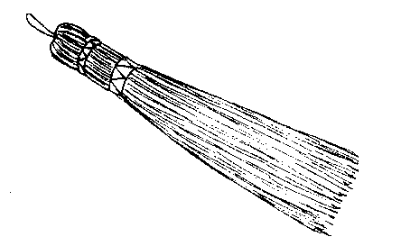

1. Identify the item
   1. Mop C. Glass
   2. Stick D. Broom
2. Name the use of the item
   1. Mopping C. Clearing
   2. Cleaning D. Spreading
3. Which of the following are the examples of indigenous musical instruments
   1. Banjo and xylophone
   2. Guitar and keyboard
   3. Visekese and guitar
   4. Drum and keyboard
4. Name the person who officiates football
   1. Coach C. Umpire
   2. Referee D. Starter

**LIFE SKILLS (20MARKS)**

1. Which of the following causes malaria
   1. Bacteria C. Virus
   2. Tsetse flies D. Plasmodium
2. Which of the following is the common example of STIs
   1. Syphilis C. Candidiasis
   2. HIV/ AIDS D. Cholera
3. Which of the following is the basic human right
   1. Discrimination
   2. Life
   3. Violence
   4. Death
4. Which of the following is the source of morals and values
   1. Family C. Culture
   2. Rallies D. Weddings
5. Identify any one cause of conflicts in class
   1. Dancing C. Eating
   2. Stealing D. Beating
6. Mention any one way of solving conflicts
   1. Fighting C. Death
   2. Justice D. Poverty
7. State any one effect of malaria
   1. Anaemia C. Sores
   2. Loss hair D. Coughing
8. Give any one way of managing stress and anxiety
   1. Speaking C. Beating
   2. Cheating D. Exercising
9. State any one example of harmful cultural practices
   1. Dances C. Story telling
   2. Chokolo D. Wedding
10. Which of the following is the physical change o of both boys and girls
    1. Deep voice
    2. Growing of pubic hair
    3. Growing breast
    4. Broader shoulder
11. Which of the following period is adolescence stage
    1. 9 years to 17 years
    2. 5 years to 8 years
    3. Birth to 4 years
    4. 18 years onwards
12. Which of the following is the effects of stress and anxiety
    1. Exercise C. Worries
    2. Death D. Cooperation
13. Which of the following is a role for both boys and girls
    1. Being group leaders
    2. Being good performers
    3. Being teachers
    4. Being chiefs
14. Which of the following is characteristics of a bad company for the peers
    1. Chamba smoking
    2. Hardworking
    3. Violence
    4. Theft
15. Which of the following is a factor which can positively affect the achievement of one’s goals
    1. Self confidence
    2. Laziness
    3. Excessive family responsibilities
    4. Exercising daily
16. When a friend of class mate force you to do something is called _____
    1. Goal
    2. Force labour
    3. Peer pressure
    4. Peer group
17. A period when a child’s body becomes sexually mature is called
    1. Adolescence C. Sexuality
    2. Puberty D. Gender
18. Which of following is one of the types of goals
    1. Long term goal
    2. Mild term goal
    3. Back term goal
    4. Front term goal
19. Which of the following is an example of physical form of abuse
    1. Shouting C. Body touch
    2. Bad remarks D. Sexual remarks
20. Which of the following is the example of moral decay
    1. Cheating in examination
    2. Identify the problem
    3. Recreational services
    4. Early marriages

**SECTION B 70(MARKS)**

**EXPRESSIVE ARTS**

1. (a) Give any two stitches used when sewing a toy
2. ______________________________________________________________________________
3. ________________________________________________________________________2marks

(b)i. Name the diagram below

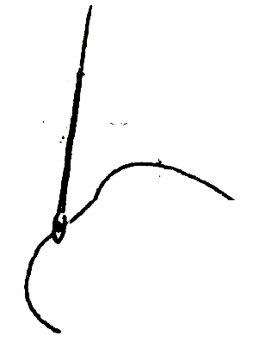

____________________________________________________________________________1mark

(ii) What is the object used for?

____________________________________________________________________________1mark

(c) What risk can the object cause?

____________________________________________________________________________1mark

1. (a) Name any two animals that move at different height level
2. ______________________________________________________________________________
3. ________________________________________________________________________2marks

(b) Name any two traditional dances that are performed in Malawi

1. ______________________________________________________________________________
2. ________________________________________________________________________2marks

(c) Name the district where tchopa dance is performed

____________________________________________________________________________1mark

1. (a) What does these symbols stand for in knitting
2. K ____________________________________________________________________________
3. C/on ____________________________________________________________________2marks

(b) Give any importance of using sports attire

1. ______________________________________________________________________________
2. ________________________________________________________________________2marks

(c) Mention any one material used for making sports attire

1. _________________________________________________________________________1mark
2. (a) Name any one musical instrument
3. _________________________________________________________________________1mark

(b) Mention any two materials used to make a banjo

1. ______________________________________________________________________________
2. ________________________________________________________________________2marks

(c) Give any two types of musical instruments

1. ______________________________________________________________________________
2. ________________________________________________________________________2marks
3. (a) Name the garment shown below

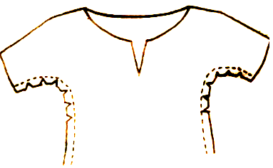

____________________________________________________________________________1mark

(b) Give the meaning of the following abbreviations

1. C/off__________________________________________________________________________
2. Sts _____________________________________________________________________2marks

(c) Give any one example of knitting stitch

1. _________________________________________________________________________1mark
2. (a) How many players are in the following games
3. Netball ________________________________________________________________________
4. Football _________________________________________________________________2marks

(b) Who officiates the following games?

1. Football _______________________________________________________________________
2. Netball __________________________________________________________________2marks

(c) Identify any one common risk in sports

1. _________________________________________________________________________1mark

**LIFE SKILLS (30MARKS)**

1. (a) Define the term environment

_________________________________________________________________________________

(b) State any two things found the environment

1. ______________________________________________________________________________
2. ________________________________________________________________________2marks

(c) Mention any two common STIs

1. ______________________________________________________________________________
2. ________________________________________________________________________2marks

(d) What do the following abbreviations stand for?

1. STIs __________________________________________________________________________
2. HIV ____________________________________________________________________2marks

(e) What is conflict?

____________________________________________________________________________1mark

(f)List any two causes of conflicts

1. ______________________________________________________________________________
2. ________________________________________________________________________2marks
3. (a) What is a goal

____________________________________________________________________________1mark

(b) State any two types of goals?

1. ______________________________________________________________________________
2. ________________________________________________________________________2marks

(c) Identify any two signs and symptoms of malaria

1. ______________________________________________________________________________
2. ________________________________________________________________________2marks

(d) Mention any two ways of preventing malaria

1. ______________________________________________________________________________
2. ________________________________________________________________________2marks

(e) Define the term peer pressure

____________________________________________________________________________1mark

1. (a) State any two causes of stress and anxiety
2. ______________________________________________________________________________
3. ________________________________________________________________________2marks

(b) Name the parasite that causes malaria

____________________________________________________________________________1mark

(c) State any two ways of managing stress and anxiety

1. ______________________________________________________________________________
2. ________________________________________________________________________2marks

(d) Give any two example of entrepreneurship

1. ______________________________________________________________________________
2. ________________________________________________________________________2marks
3. (a) State any two ways in which peer pressure can be resisted
4. ______________________________________________________________________________
5. ________________________________________________________________________2marks

(b) State any two effects of chokolo

1. ______________________________________________________________________________
2. ________________________________________________________________________2marks

**END OF QUESTION PAPER**