**2025 NGAKWEST EXAMINATIONS**

**PRIMARY SCIENCE|100 MARKS**

**DATE: _________________________**

**TIME ALLOWED: ___________________________**

**NAME OF CANDIDATE** (SURNAME FIRST): __________________________________

**NAME OF SCHOOL:** _________________________________________________________

**ZONE:** EKWENDENI **DISTRICT:** MZIMBA

**MULTIPLE CHOICE:** Encircle the correct answer

**AGRICULTURE**

1. The method of applying fertilizer to the either side of a plant is called?
2. Banding
3. Folia’s
4. Broadcasting
5. Dollop
6. Which of the following vegetables is a tuber?
7. Cowpeas
8. Cucumber
9. Beetroot
10. Cauliflower
11. Cassava Cuttings are planted at angle in order to prevent?
12. Exposure to direct sunlight
13. Them from rotting
14. Them being blown off by wind
15. Termites from attacking the cuttings
16. Which of the following is a characteristics of loam soil ?
17. Holds moderate amount of water
18. Small air spaces
19. Has little amount of nutrients it is difficult
20. It is difficult to till
21. Which of the following trees add nutrients to the soil?
22. Msangu
23. Masuku
24. Mango
25. Bwemba
26. Which of the following trees belong to silviculture?
27. Rape
28. Pumpkins
29. Blue gum
30. Marigold
31. In which of the following records are the daily activities on the farm shown
32. Crop record
33. Layers record
34. Labour record
35. Field operation record
36. Which of the following is an activity in marketing?
37. Planting
38. Processing
39. Supplying
40. Harvesting
41. Which of the following is a way of improving the quality of water?
42. Cutting down trees
43. Construction of dams
44. Adding Chlorine
45. Putting wastes in rivers
46. Which of the following is a breed of rabbit?
47. Angora
48. Afrikander
49. California
50. Jersey

**Figure 1** is a diagram of a crop grown in Malawi use it to answer questions that follows (11 and 12)

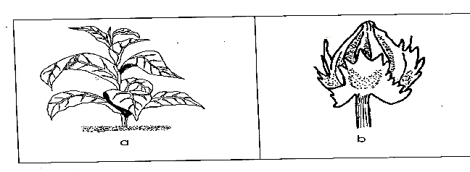

1. Name the type of crop
2. Strawberry
3. Tobacco
4. Cotton
5. Sunflower
6. To which group of crops does the diagram belong
7. Cash crops
8. Food crops
9. Indigenous crops
10. None of the above
11. What causes Anthrax in goats
12. Bacteria
13. Virus
14. Fungi
15. Protozoa
16. To which sub-branch of agriculture under animal production does the rearing of landrace belong?
17. Rabbitry
18. Goat farming
19. Pig farming
20. Sheep farming
21. Which of the following components of soil is made up decaying animal parts?
22. Soil air
23. Soil water
24. Organic matter
25. Inorganic matter
26. Which of the following is an improved local breed of chicken that is kept for both eggs and meat?
27. Indian river
28. Black Australian
29. White leghom
30. White broiler
31. Which of the following is a variety of cassava?
32. Manipintar
33. RG1
34. CG7
35. Silira
36. Which characteristic of fish ensures the harvesting within a short period of time?
37. Have eggs
38. Easy to handle
39. Grow fast
40. Resistant to diseases

**Figure 2** is a diagram of a chicken product. Use it to answer question 19.

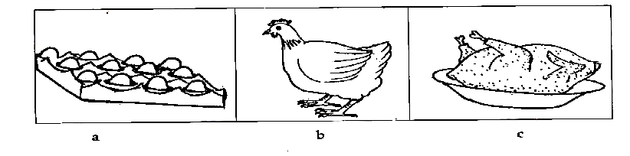

1. Identify the chicken product
2. Live chicken
3. Dressed chicken
4. Unfinished chicken
5. Washed chicken
6. Which of the following types of fish survives in salty water?
7. Mlamba
8. Chilunguni
9. Chambo
10. Mphende

**SCIENCE AND TECHNOLOGY**

1. Which of the following is a mineral stain?
2. Wax
3. Tar
4. Ink
5. Soot
6. Some people become vegetarians because of
7. Gender
8. Funeral rites
9. Animal welfare
10. Age
11. Which of the following conditions is not necessary for seed germination?
12. Soil
13. Air
14. Temperature
15. Water
16. The following are marketing technologies except?
17. Telephone
18. Ox-cart
19. Newspaper
20. Flour sieve
21. Which diseases is associated with loosing teeth?
22. Scurvy
23. Anemia
24. Kwashiorkor
25. Marasmus

**Figure 3** is a diagram of deficiency diseases use it answer questions 26 and 27

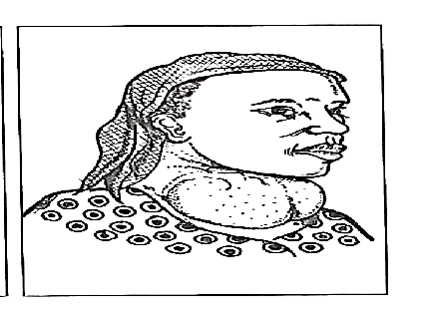

1. Name the deficiency disease
2. Scurvy
3. Goiter
4. Night blindness
5. Anemia
6. Which of the following is a way of treating the disease?
7. Provision of food rich in vitamin D
8. Provision of food rich in vitamin C
9. Provision of food rich in vitamin A
10. Provision of food rich in Iodine
11. Which of the following is an emotional change in adolescent?
12. Experience wet dreams
13. Frequent change in mood
14. Develop deep voice
15. Grow taller and heavier
16. The term coding means
17. Sending message
18. Reviving information
19. Interpreting a message
20. Which of the following is a modern food preservation technology?
21. Sun-drying
22. Smoking
23. Cunning
24. Salting
25. Which of the following liquids can dissolve Vaseline?
26. Water
27. Paraffin
28. Milk
29. Orange juice
30. Why should fish be turned from time to time during roasting?
31. To make it tender
32. To improve its taste
33. To cook it evenly
34. To improve its flavour
35. The liquid that contains sperms is called?
36. Zygote
37. Fluid
38. Amnion
39. Semen
40. Which activities can destroy the environment?
41. Poaching
42. Composting
43. Constructing dams
44. Planting trees
45. Which of the following is a third step in laundering?
46. Washing
47. Drying
48. Soaking
49. Sorting
50. Blood in veins is dark ren in colour because it has_______
51. Less oxygen
52. More oxygen
53. More nutrient
54. Less nutrients
55. Which of the following is made from artificial fibres?
56. Linen
57. Cotton
58. Nylon
59. Woolen
60. Which food provides the body with water?
61. Groundnuts
62. Fruits
63. Margarine
64. Potatoes

**During an experiment** on conditions necessary for seed germination. Tapiwa put bean seeds in two transparent containers and covered them with soaked cotton container A. was put in a refrigerator while container B. was not. Use this information to answer questions 39 and 40.

1. What condition necessary for seed germination was being investigated?
2. Air
3. Soil
4. Warmth
5. Moisture
6. What would happen to the experiment after five days?
7. Seeds in container A only will germinate
8. Seeds in all containers will not germinate
9. Seeds in container B only will germinate

**SECTION B 60 MARKS**

**AGRICULTURE**



(a) Define poultry farming

______________________________________________________________________

_______________________________________________________________(2 Marks)   
(b) Give two problems associated with agricultural marketing

______________________________________________________________________

_______________________________________________________________(2 Marks)



(a) Explain one importance of agriculture on national level ?

______________________________________________________________________

_______________________________________________________________(2 Marks)

(b) Mention three characteristic of land that affect agricultural production?

____________________________________________________________________

_____________________________________________________________(3 Marks)



(a) state two characteristics of agroforestry tree species?

_____________________________________________________________________

_______________________________________________________________(3 Marks)

(b) Explain one way how trees conserve water?

______________________________________________________________ (2 Marks)



(a) describe cross breeding as a method of improving cattle?

______________________________________________________________________

________________________________________________________________(2 Mark)

(b) figure 4 is a diagram of a system of keeping chickens use it to answer questions   
 that follows

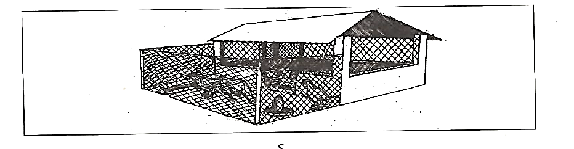

(i). Name the system of keeping chickens

_________________________________________________________(1 Marks)

(ii) name one disadvantage of the system above

_________________________________________________________(2 Marks)



(a) explain why the pond needs to be sited considering the direction of the prevailing  
 wind of the area?

_______________________________________________________________(2 Marks)

(b) mention two animal husbandry practices

______________________________ ________________________________ (2 Marks)



(a) mention two examples of tree flowers

__________________________________ ____________________________(2 Marks)

(b) define farming calendar

______________________________________________________________________

______________________________________________________________(2 Marks)

(c) classify the following fruits into indigenous and exotic: Tamarind, Pawpaw,   
 Baobab, Peaches

Indigenous__________________________________________________(2 marks)

Exotic_____________________________________________________ (2 marks)

**SCIENCE AND TECHNOLOGY**



(a) List down two technologies for marketing

__________________________________ ____________________________(2 Marks)

(b) state two negative effects of improving the quality of products

__________________________________ _________________________(2 Marks)



(a) **Figure 5** is a diagram of traditional technology for sending messages use to   
 answer questions that follows

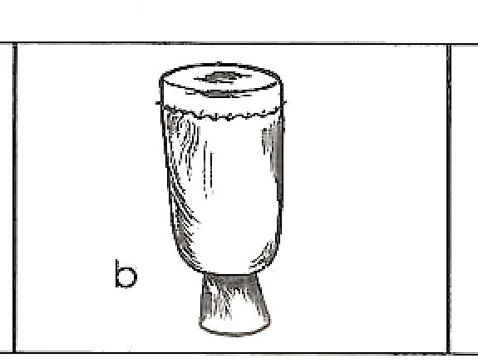

1. Identify the technology in figure 5 _______________________________________________________(1 Mark)
2. Explain one way in which the technology in figure 5 can be used to send messages

_______________________________________________________(2 Marks)

1. State one disadvantage of the technology in figure 5

_______________________________________________________(2 Marks)



(a) mention two ways of improving the nutritional value of food

__________________________ ___________________________(2 Marks)

(b) figure 6 is a diagram showing a method of cooking.  
 Use it to answer questions that follows.

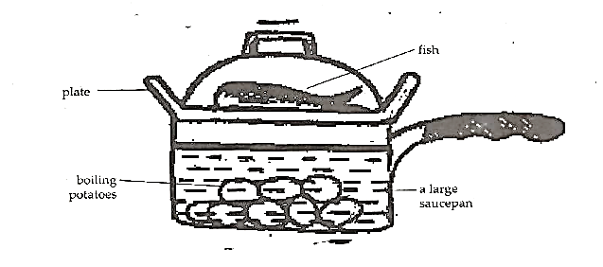

(i). Identify the method of cooking fish

____________________________________________________________(1 Mark)

(ii). Give one way in which this method of cooking is economical

____________________________________________________________(1 Mark)



(a) Mention two types of frying method of cooking

_____________________________ ________________________________(2 Marks)

(b). Describe two common food taboos and beliefs

______________________________________________________________(2 Marks)



(a) classify the following into Omnivores and Carnivores : Chicken, Snake,Pig,Hawk

Carnivore:_________________________________________________(2 marks)

Omnivores :________________________________________________(2 marks)

2. Name two groups of vertebrate animals

_______________________________________________________________(2 Marks)

b. State any two components of report for a scientific investigation

_______________________________________________________________(2 Marks)

1. (a) Name the female reproductive organ which produces egg cells

________________________________________________________________(1 Mark)

(b) name the part of the brain which control balance

________________________________________________________________(1 Mark)

(c ) State the function of gallbladder in the digestive system

________________________________________________________________(1 Mark)

1. Explain how each of the following indigenous technologies could be improved
2. An arrow________________________________________________

________________________________________________________(1 Mark)

1. A pestle__________________________________________________

________________________________________________________(1 Mark)

**THE END**

PRIMARY SCIENCE MARKING KEY

SECTION A

1. D
2. C
3. B
4. A
5. A
6. C
7. D
8. B
9. C
10. A
11. C
12. A
13. A
14. C
15. C
16. B
17. D
18. C
19. B
20. B
21. C
22. C
23. C
24. D
25. A
26. B
27. D
28. B
29. A
30. C
31. B
32. C
33. D
34. A
35. C
36. A
37. C
38. B
39. C
40. D