**2025 NGAKWEST EXAMINATIONS**

**SOCIAL & BIBLE KNOWLEGDE|100 MARKS**

**DATE: _________________________**

**TIME ALLOWED: __________________________**

**NAME OF CANDIDATE** (SURNAME FIRST): __________________________________

**NAME OF SCHOOL:** _________________________________________________________

**ZONE:** EKWENDENI **DISTRICT:** MZIMBA

**INSTRUCTIONS**

1. This paper Contains 8 printed pages. Please check.
2. Write your name on each page of this paper.
3. This paper consists of three sections: A, B, and C.
4. Answer all questions in Sections A and B. In section A circle the letter representing correct answer. In section C, Write your answers in the spaces provided on each question.
5. Please make sure you have written the name of your school and zone on the question paper on the spaces provided.
6. Hand in your worked question paper to the invigilator when time is called to stop writing.

**Section A (30 marks)**

**Answer all questions in this section Encircle the letter representing the correct answer.**

* 1. Which of the following countries used guerilla wars as a liberation strategy? A. South Africa and Angola
     1. South Africa and Zambia
     2. Mozambique and Zimbabwe
     3. Zambia and Zimbabwe
  2. Which organisation was formed soon after World War II?

A. United Nations

* + 1. League of Nations
    2. Commonwealth
    3. European Nation
  1. Which of the following systems of government controls all the wealth of the state?

A. Democracy

* + 1. Monarch
    2. Socialist
    3. Autocratic
  1. Which of the following people were looking for grazing land and water for their livestock?
     1. The Chewa
     2. The Tonga
     3. The Ngoni
     4. The Yao
  2. Which of the following factors would lead to road accidents?

A. Using a licensed driver

* 1. Overtaking at a flat area
  2. Driving vehicles which are road worthy
  3. Neglecting road signs and traffic rules

1. In which season do trees lose their leaves in Malawi?

A. Cool and wet

* 1. Hot and dry
  2. Cool and dry
  3. Hot and wet

1. Which of the following is the economic importance of Malunje Mountain?
   1. It provides people with fresh water
   2. It is a home of wild animals
   3. It attracts people who bring foreign currency
   4. It has fertile soils for crops
2. Where is the headquarters of United Nations Organisation?
   1. New York
   2. Addis Ababa
   3. Brussels
   4. Paris
3. Which of the following describes the desert vegetation?

A. Vegetation is always green

* 1. Grass germinates when rains come
  2. Vegetation has waxy leaves and thorns
  3. Grass is tall and covers many areas

**Figure 1** is a diagram of a weather instrument. Use it to answer questions 10, 11, and 12.

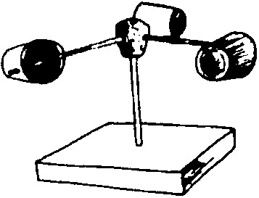

1. Identify the instrument.
   * 1. Rain gauge
     2. Thermometer
     3. Barometer
     4. Anemometer
2. The instrument is used for measuring
   * 1. rainfall
     2. temperature
     3. wind speed
     4. weather
3. where is an instrument kept?
   * 1. in a house
     2. in a storeroom
     3. in a classroom
     4. in a Stevenson’s screen
4. Which of the following is used to find the exact location of s place on a map?
   * 1. Reference points
     2. Scale of the map
     3. Cardinal points
     4. Latitudes
5. When does a bill becomes a law?
   1. When the parliament has approved it
   2. When the cabinet has approved it
   3. When the President has signed for it
   4. When the commissioner has signed for it
6. Which of the following districts in Malawi experienced the worst flush floods in 2001?

A. Karonga and Lilongwe

1. Chikwaw and Neno
2. Phalombe and Nkhotakota
3. Nsanje and Likoma
4. Which of the following tax is collected from manufactured goods within the country?

A. Exercise duty

* 1. Customs duty
  2. Income tax
  3. Surtax

1. Which structure of the government is responsible for making laws?
   1. Judiciary
   2. Councilors
   3. Executive
   4. Legislature
2. Which of the following institutions promotes the sustainability of the environment in Malawi?

A. Extension Planning Area

* 1. Veterinary Department
  2. Forest Department
  3. Development Fund

1. Which of the following describes goods carried by an aeroplanes?
   1. Machine
   2. Passenger
   3. Parcel
   4. Cargo
2. Which of the following tribes in Malawi was the first to be in contact with the Arabs.
   1. Lomwe
   2. Chewa
   3. Yao
   4. Tumbuka
3. Which of the following is the function of the Department for International Development (DFID)?
   1. Supervising construction works
   2. Providing teaching and learning materials
   3. Lending money to people
   4. Providing medicines
4. Which of the following encourages people in self-projects?

A. Member of Parliament

* 1. Ward Councillor
  2. Traditional Authority
  3. District Commissioner

1. Which of the following is a right of detainees?

A. Right to play

* 1. Right to good salary
  2. Right to good food
  3. Right to employment

1. Which of the following mineral is used for wrapping and packaging food stuffs?

A. Aluminum

* 1. Copper
  2. Diamond
  3. Gold

1. Which of the following is a major factor that affects trade?
   1. Language
   2. Resources
   3. Culture
   4. Climate
2. Which of the following terms refer to the culturally defined aspects of being male or female.

A. Gender

* 1. Gender equity
  2. Gender balance
  3. Gender roles

1. Which of the following are causes of drug and substance abuse?
   1. Ignorance
   2. Desire to be famous
   3. Healing of diseases
   4. Peer pressure
   5. 1, 2, and 4
   6. 1 only
   7. 2 and 3
   8. 1 and 4

1. Which of the following European countries colonized Ivory Coast?
   1. Germany
   2. France
   3. Portugal
   4. Britain
2. Which of the following groups of people were involved in slave trade in East and Central Africa?
   1. Nkhamanga
   2. Arabs
   3. Ngoni
   4. Lomwe
3. By registering at the polling centre, a person is exercising a right to:
   1. Education
   2. Employment
   3. Life
   4. Vote

**Section B (35 marks)**

**Answer all the five questions in the spaces provided.**

1. a). Give only one factor that promotes gender balance at school.

______________________________________________________________________________________________ (1 mark)  
b). Mention any two examples of notable abolitionists of slave trade.

i. __________________________________________ ii. ___________________________________________ (2 marks)

c). In what ways are minerals important? Give two points.

i. __________________________________________ ii. ___________________________________________ (2 marks)

d). State any two consequences of drug and substance abuse.   
i. __________________________________________ ii. ___________________________________________ (2 marks)

**Figure 2** is a diagram showing map of Africa. Use it to answer questions 32 a, b, and c.

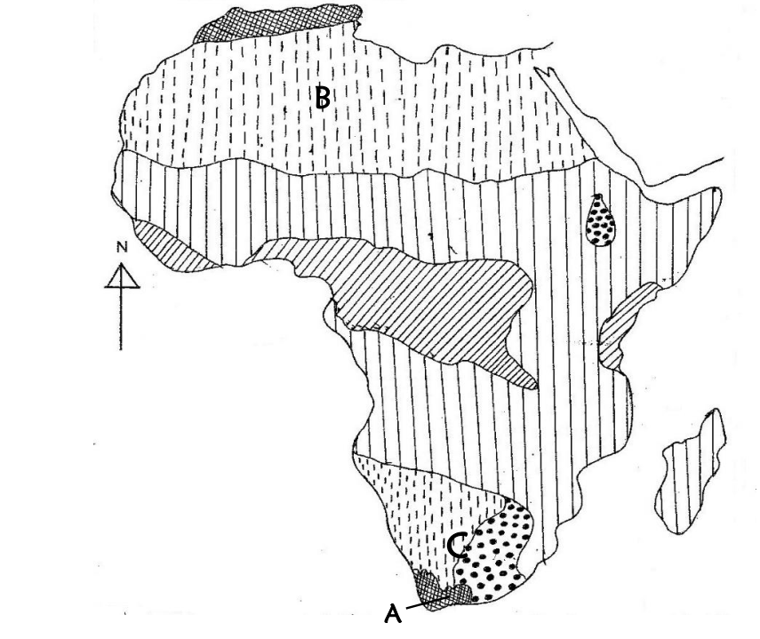

1. a). Name the climate marked A.

________________________________________________________________ (1mark)  
 b). Identify the deserts marked B and C.

B. _____________________________________________ C_________________________________________ (2 mark)

c). Mention any two crops that grow well in the climate labelled A.

i. _______________________________________ii. __________________________________________ (2 mark)

d). State any two human practices which prevent soil erosion.

* + - 1. _________________________________________ ii _____________________________________________ (2 marks)

**Figure 3** is a diagram of a Map. Showing trade routes. Use it to answer questions that follow.

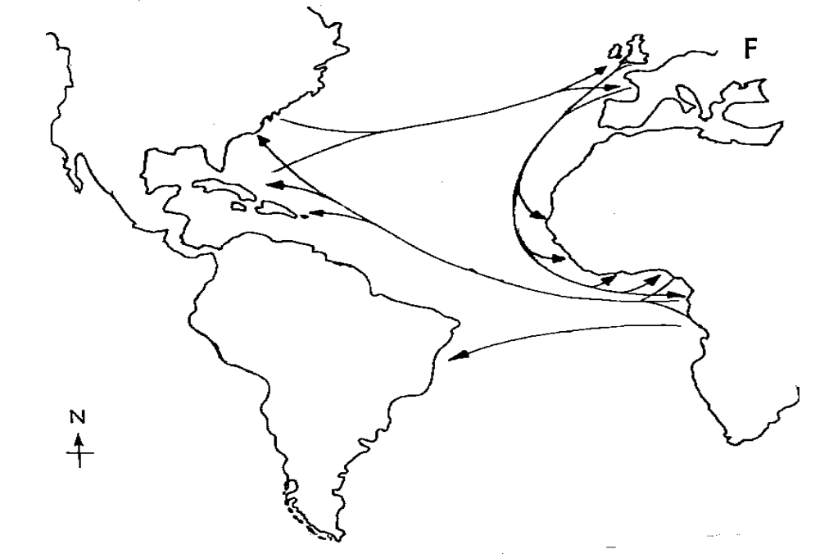

1. a). Identify two continents that were involved in a trade routes shown above.
2. _________________________________________ ii. _________________________________________ (2 mark)

b). Mention another name for West African Slave Trade. _____________________________________________ (1 mark)

c). Which two raw materials were obtained from the area labelled F?

i. _________________________________________________ ii. _____________________________________ (2marks)

d). Explain the two proofs for the spherical shape of the earth.

i. _________________________________________________ ii ______________________________________(2 marks)

1. a). Give any two precautionary measures against natural disasters.

i. _________________________________________________ ii ______________________________________(2 marks)

b). Why is Malawi described as a landlocked country?

__________________________________________________________________________________________ (1 mark)

c). What was the work of the early Missionaries in Malawi? Give any two points.

i. __________________________________________________ ii_____________________________________ (2 marks)

d). Explain one disadvantage of modern technology in Malawi.

_________________________________________________________________________________________ (2 marks)

1. a). List down any two traffic rules which motorists should follow on the road.

i. _________________________________________________ ii. _____________________________________ (2 marks)

b). Mention any two non-governmental organizations that provide humanitarian assistance to people during famine  
 and cyclones.

i. _________________________________________________ ii. _____________________________________ (2 mark)

c). Name any two contributions of the early kingdoms to the present Malawi.

i. _________________________________________________ ii . ____________________________________ (2 mark)

d). Define the term ‘forest’.

______________________________________________________________________________________________

_______________________________________________________________________________________ (1 mark)

**SECTION C: (35 Marks)  
BIBLE KNOWLEDGE**

**Answer all the five questions in the spaces provided. Your answers must be in short clear sentences.**

1. a). Name two types of food God provided to the Hebrews in the dessert.

i. _____________________________________________ ii. ______________________________________ (2 mark)

b). How did the following people communicate with God?

* + - 1. Elijah _________________________________________________________________________________ (1 mark)
      2. Hannah, Paul, and Silas _________________________________________________________________ (1 mark)

c). Define the following:

i. Resurrection _____________________________________________________________________________ (1 mark)

ii. Ark of the Covenant ___________________________________________________________________ (1 mark)

d). Who is the Judge?

__________________________________________________________ ____________________________ (1 mark)

1. a). Why were the disciples afraid when they saw Jesus walking on the water?

_________________________________________________________________________________________ (2 marks)

b). Name two sisters of Lazarus.

i. _________________________________________________ ii. _____________________________________ (2 marks)

c). Mention two ways of conserving the environment at school.

* + - 1. ______________________________________________ ii. ____________________________________ (2 marks)

d). State the roles of women and men in the church.

Women ____________________________________________ Men___________________________________ (2 marks)

**Figure 4** is a diagram showing a certain city in Jerusalem. Use it to answer question 38 a.

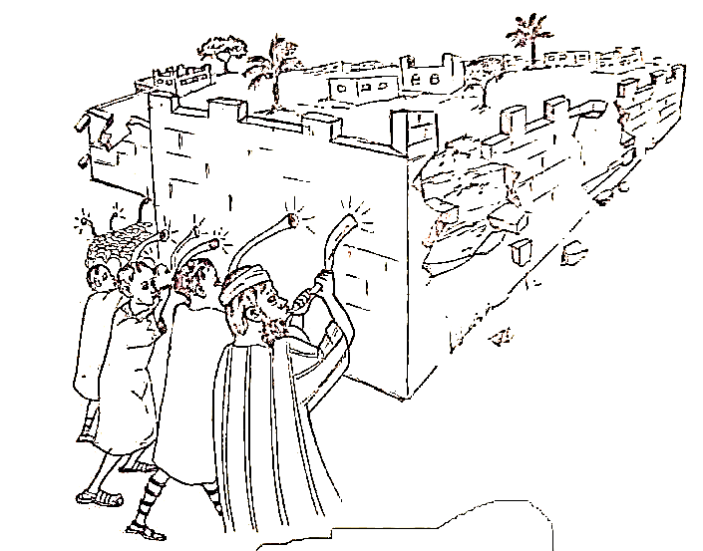

1. a). Explain how the Israelites managed to conquer the city of Jericho.

__________________________________________________________________________________________ (2 marks)

b). Give two ways how leaders are chosen church and in politics.

* + 1. In church ________________________________________________________________________________
    2. In politics _______________________________________________________________________________ (2 marks)

c). Why was Saul rejected by God? ________________________________________________________________ (1 mark)

d). Name two ways how the messages of prophets were carried out.

* + 1. ______________________________________________________________________________________
    2. _________________________________________________________________________ _____________(2 marks)

1. a). How can Christians fight against corruption in the society? Give two ways.
   * 1. ________________________________________________ ii. ____________________________________ (2 marks)

b). Why did Jesus use parables in His teachings?

___________________________________________________________________________________________ (1 mark)

c). Mention any two examples of drugs and substances that are commonly abuse by the   
 youths in the society.

i. ___________________________________________________ ii. ____________________________________ (2 marks)

d). Name two types of sacraments administered by Jesus.

i. ______________________________________________ ii. ____________________________________ (2 mark)

40. a). Give any two events that are occurred when Jesus was on the cross.

i. _______________________________________________ ii. _____________________________________(2 mark)

b). Why should we forgive each other? ______________________________________________________________(1 mark)

c). List down any two roles of apostles after the death of Jesus Christ.

* + 1. ________________________________________________ ii. ____________________________________ (2 marks)

d). i. Identify one king who found nothing wrong with Jesus but ridiculed and mocked him.

______________________________________________________________________________________ (1 mark)

ii. Name the place where Jesus Christ was crucified. _______________________________________________ (1 mark)

**THE END!**