**THE LILONGWE URBAN DISTRICT EXAMINATION BOARD**

**2023 END OF THIRD TERM EXAMINATIONS FOR STD 6**

**PRIMARY SCIENCE**

**(100 Marks)**

**Time allowed: ……………**

**Date: ……./…../…….**

**NAME OF CANDIDATE: ________________________________________________________________**

**(Surname first)**

**NAME OF SCHOOL: ___________________________________________________________________**

**INSTRUCTIONS**

1. This paper contains **6pages.** Please check.
2. This paper has **two** sections **A** and **B**. section **A** consists of **40 multiple choice** questions carrying

**1mark** each. Encircle a letter of your choice representing the right answer to each question. **Section B** has **8 structures** questions. Write your answers to this section on the question paper in the spaces provided. The maximum number of marks for each answer is indicated against the questions.

1. Answer **all** questions
2. **IMPORTANT**
   * Please make sure you have written your **name**, **school name**, on the question paper.
   * Please hand in your filled-in question paper to the invigilator at the end of the examination

**SECTION A (40MARKS)**

**MULTIPLE CHOICE**

**AGRICULTURE**

1. To which sub branch of Agriculture does the growing of crops belong:
   1. Horticulture C. Olericulture
   2. Agronomy D. Floriculture
2. Give any one way of improving the quality of water
   1. Avoid cutting down trees
   2. Construction of boreholes
   3. Provision of piped water
   4. Adding chroline to dirty water
3. Why is early land preparation important
   1. Allows buried plants residues to rot
   2. Slows down the speed of running water
   3. Composed of one variety of trees
   4. Attracts pests and diseases
4. Why do you call the act of birds eating each other?
   1. Culling C. Cannibalism
   2. Ventilation D. Contamination

**Figure 1 is a diagram. Use it to answer question 5 and 6**

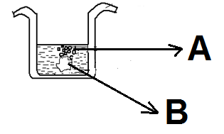

1. The parts marked A and B are
   1. Water and air
   2. Bubbles and water
   3. Lump of soil and air
   4. Lump of soil and bubbles
2. The presence of bubbles in the experiment above implies that:
   1. The soil contains air
   2. The soil has minerals salts
   3. The soil contains organic matter
   4. The soil has high acidic rate
3. Which method of irrigation is suitable for rice production
   1. Basic irrigation
   2. Sprinkler irrigation
   3. Flooding irrigation
   4. Drip irrigation
4. Why are farm records important to a farmer
   1. Source of labour
   2. For budgeting and planning
   3. Source of food
   4. Collecting inputs
5. How can you control dumping off in a nursery
   1. Reducing the frequency of water
   2. Frequent weeding
   3. Wrong spacing
   4. Use of poor planting materials
6. Why should farmers paint a wheel barrow?
   1. To reduce friction
   2. To prevent rusting
   3. To make it strong
   4. To attract customers
7. Groundnuts and beans are examples of:
   1. Roots C. Legumes
   2. Cucumbers D. Flowers
8. What type of chicken house is recommended for free range system
   1. Tradition
   2. Semi – intensive
   3. Battery cage
   4. Deep litter
9. How can termites be controlled in a woodlot?
   1. Applying chemicals
   2. Fencing the woodlot
   3. Chasing them away
   4. Burning the bush
10. State one importance of soil to crops
    1. Building lakes
    2. Holds the plants
    3. Home of animals
    4. Avoid pest and diseases
11. Which part of the maize is attacked by a weevil
    1. Leaves C. Roots
    2. Stalk D. Maize grain

**Figure 2 is a farm tool. Use it to answer question 16 and 17**

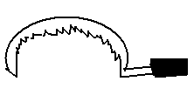

1. Name the farm tool
   1. Rake C. Sickle
   2. Hand trowel D. Hand trowel
2. What is the main use of the farm implement?
   1. Cutting down of trees
   2. Harvesting rice
   3. For weeding crops
   4. For pruning
3. A farmer collected 10 trays of chicken eggs, if he sold all the eggs at K1000.00 per tray. How much money did the farmer get?
   1. K10 000.00
   2. K100 000.00
   3. K110 000.00
   4. K1000.00
4. What type of feed is given to a day old broiler?
   1. Growers marsh
   2. Layers marsh
   3. Starter marsh
   4. Finisher marsh
5. Which of the following is a factor to consider when selecting goods seeds for planting
   1. Colourful C. Beautiful
   2. Nice D. Purity

**SCIENCE AND TECHNOLOGY**

1. Which of the following is the first stage of scientific investigation
   1. Making conclusion
   2. Knowing the problem
   3. Planning investigation
   4. Making predictions
2. Which of the following is a tissue which attach muscles to bones
   1. Tendon C. Triceps muscles
   2. Femur D. Ligaments
3. Mention one nutritional deficiency diseases
   1. Malaria C. Marasmus
   2. Dysentery D. Tuberculosis
4. Which of the following worms can be prevented by washing fruits before eating
   1. Tape worms C. Hook worms
   2. Roundworm D. Earthworms
5. Which of the following foods can be preserved by both salting and drying methods
   1. Fish C. Maize
   2. Groundnuts D. Beans
6. How does guitar produce sound?
   1. By blowing C. By shaking
   2. By plucking D. By beating
7. The process whereby green plants make their own food by using sunlight is called
   1. Pollination C. Photosynthesis
   2. Hypothesis D. Variable

**Figure 3 is a diagram. Use it to answer question 29 and 29**

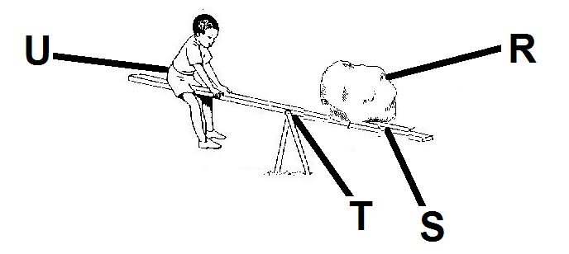

1. Which of the following letters represents the effort
   1. R C. T
   2. S D. U
2. Which of the following ways could make the work easier?
   1. Using a shorter beam
   2. Increasing the distance between T and U
   3. Increasing the distance between T and S
   4. Pushing the beam harder
3. Name two types of refuse
   1. Dry and wet
   2. Dry leaves and dust
   3. Food waste and ashes
   4. Dry and cold
4. Which of the following is not a sense organ
   1. Skin C. Ear
   2. Eye D. Mouth
5. Which of the following is an example of omnivores
   1. Lions C. People
   2. Hyena D. Cattle
6. The ability to do work is known as
   1. Light C. Sound
   2. Energy D. Work
7. Which of the following are the main types of meals
   1. Dinner, chip and lunch
   2. Breakfast, juice and lunch
   3. Breakfast, juice and nsima
   4. Breakfast, lunch and dinner
8. Which of the following machines uses the principles of levers?
   1. Pulley C. Wedge
   2. Screw D. Spanner
9. The following are properties of liquids except _____
   1. Can be compressed
   2. Definite shape
   3. Can take shape of a container
   4. Can be poured
10. The process of changing solids into gases is called___________
    1. Solidification
    2. Freezing
    3. Sublimation
    4. Evaporation
11. Which of the following is the reason for pressing during laundering of garments
    1. To remove wrinkles
    2. To remove dirt
    3. To protect clothes from insects
    4. To ensure complete dryness
12. Mention two types of energy?
    1. Heat and sun energy
    2. Light and bulb energy
    3. Heat and light energy
    4. Light and solar energy
13. Which of the following is the name of a parasite that causes malaria
    1. Mosquito C. Bacteria
    2. Plasmodium D. Trypanosome

**SECTION B**

**AGRICULTURE**

1. (a)Mention any two sub – branches of agriculture under crop production
2. ______________________________________________________________________________
3. ________________________________________________________________________2marks

(b)Give any one importance of forest?

____________________________________________________________________________1mark

(c) State any two ways of keeping water safe

1. ______________________________________________________________________________
2. ________________________________________________________________________2marks
3. (a) What are two main aims of agriculture as a business
4. ______________________________________________________________________________
5. ________________________________________________________________________2marks

(b) Write any two activities involved in tree nursery management?

1. ______________________________________________________________________________
2. ________________________________________________________________________2marks

(c) Give any one characteristic of a good cock?

1. _________________________________________________________________________1mark
2. (a) Mention three systems of keeping chicken
3. ______________________________________________________________________________
4. ______________________________________________________________________________
5. ________________________________________________________________________3marks

(b) Give any two products that can be obtained from chickens

1. ______________________________________________________________________________
2. ________________________________________________________________________2marks

**Figure 4 is an illustration. Use it to answer questions 44a , b and c**

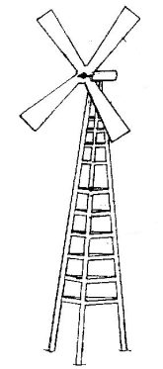

1. (a) i. Identify the farm implement

____________________________________________________________________________1mark

(ii) Give any two uses of the farm implement identified in question 45a(i)

1. ______________________________________________________________________________
2. ________________________________________________________________________2marks

(b) Briefly explain the difference between layers and broilers

1. ______________________________________________________________________________
2. ________________________________________________________________________2marks

(c) How can be roundworms be prevented in chickens

1. _________________________________________________________________________1mark
2. (a) What is pruning

____________________________________________________________________________________________________________________________________________________________2marks

(b) Name two materials used for mulching tree seedlings

1. ______________________________________________________________________________
2. ________________________________________________________________________2marks

**The table below shows a farm record. Study it to answer the questions 46a, b and c**

|  |  |  |  |
| --- | --- | --- | --- |
| **Crop** | **Field / plot** | **Hectare** | **Yield** |
| Maize | 1 | 1 | 5000kg |
| Cassava | 2 | 11 | 1000kg |
| Groundnuts | 3 | 5 | 25000kg |
| Vegetables | 4 | 4 | 500kg |

1. (a) i. What name is given to the farm record?

____________________________________________________________________________1mark

(b) Which hectare gave a farmer more yields that the other

1. ______________________________________________________________________________
2. ________________________________________________________________________2marks

(c) List down any two crop husbandry practices

1. ______________________________________________________________________________
2. ________________________________________________________________________2marks

**SCIENCE AND TECHNOLOGY**

1. (a) What is a joint?

____________________________________________________________________________1mark

(b) State two ways of preventing marasmus

1. ______________________________________________________________________________
2. ________________________________________________________________________2marks

(c) Give any two reasons for cooking food?

1. ______________________________________________________________________________
2. ________________________________________________________________________2marks
3. (a) List one function of hair found in the nose
4. _________________________________________________________________________1mark

(b) Why is food preservation important (give two points)

1. ______________________________________________________________________________
2. ________________________________________________________________________2marks

(c) Give two reasons why information and communication technology is important

1. ______________________________________________________________________________
2. ________________________________________________________________________2marks
3. (a) Mention two effects of common accidents
4. ______________________________________________________________________________
5. ________________________________________________________________________2marks

(b) Identify parts of indigenous technology

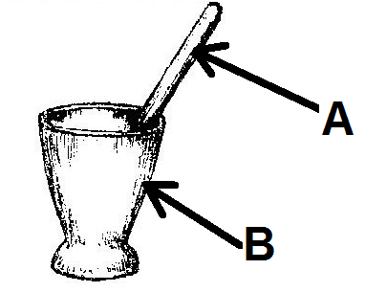

1. ______________________________________________________________________________
2. ________________________________________________________________________2marks

(c) What is the use of the technology?

____________________________________________________________________________1mark

1. (a) State two items you would make out of old string materials
2. ______________________________________________________________________________
3. ________________________________________________________________________2marks

(b) Explain two factors to consider when planning packed meals

1. ______________________________________________________________________________
2. ________________________________________________________________________2marks

(c) Give one example of information and communication technologies that is used in your community

1. _________________________________________________________________________1mark
2. (a) Give one importance of keeping the surrounding clean
3. _________________________________________________________________________1mark

(b) State any two dangers of light energy

1. ______________________________________________________________________________
2. ________________________________________________________________________2marks

(c) Why is first aid treatment important (give two points)

1. ______________________________________________________________________________
2. ________________________________________________________________________2marks
3. (a) What happens to candle wax when gets heated?

____________________________________________________________________________1mark

(b) Give any two functions of human skeleton?

1. ______________________________________________________________________________
2. ________________________________________________________________________2marks

(c) Write down any two food taboos which you are familiar with

1. ______________________________________________________________________________
2. ________________________________________________________________________2marks

**END OF QUESTION PAPER**