** MKUKULA ZONE EXAMINATION BOARD**

**2024 - 2025 PRIMARY SCHOOL LEAVING CERTIFICATE MOCK EXAMINATION**

**STANDARD 8**

**PRIMARY SCIENCES**

**(100 MARKS)**

**Subject number: P163**

**Time allowed: 2 hr.**

**Date: ____/_____/ 2025**

**NAME OF CANDIDATE: ____________________________________________________________________**

***(Surname first)***

**NAME OF SCHOOL: ________________________________________________________________________**

**Instructions**

|  |  |  |  |
| --- | --- | --- | --- |
| Question Number | Tick question 41 – 52 if answered | Do not write in these columns | |
| 1 – 20 |  |  |  |
| 21 - 40 |  |  |  |
| 41 |  |  |  |
| 42 |  |  |  |
| 43 |  |  |  |
| 44 |  |  |  |
| 45 |  |  |  |
| 46 |  |  |  |
| 47 |  |  |  |
| 48 |  |  |  |
| 49 |  |  |  |
| 50 |  |  |  |
| 51 |  |  |  |
| 52 |  |  |  |
|  | |  |  |

1. This paper contains **7 pages** please check.
2. Write your **examination number** on each

page of this page.

1. This paper has two sections **A** and **B**
2. Answer all questions.
3. Follow instructions for each section Carefully.

**Important**

1. Please make sure you have written your **name**

and **examination number** in the spaces

provided.

1. Hand in your question paper to the

invigilators when the time is called to stop

writing.

**AGRICULTURE**

1. Which of the following is a raw material from poultry?
2. Shoes
3. Feather
4. Leather
5. Hide
6. Which of the following practises leads to water pollution?
7. Applying organic matter
8. Cultivating on steep slope
9. Using contour ridges
10. Using vegetative cover
11. To which sub-branch of agriculture does the growing of maize belong to?
12. Agriculture
13. Horticulture
14. Floriculture
15. Agronomy
16. Which of the following breeds of cattle is kept for beef?
17. Jersey
18. Boron
19. Arshire
20. Freshan
21. Which of the following method can help to control parasites of fish in a pond?
22. Scaring them away
23. Fencing the pond
24. Setting traps
25. Applying lime after drying
26. Identify the method pf propagating pineapple?
27. Budding
28. Sucker
29. Grafting
30. Seed
31. Which of the following is the most effective way of preventing dumping off in vegetable?
32. Treating the seed
33. Crop hygiene
34. Crop rotation
35. Avoid over watering
36. The coarseness and fineness of soil refers to __________?
37. Soil texture
38. Soil profile
39. Soil conservation
40. Soil structure
41. Why farmers are advised to face away when spraying chemicals?
42. To protect clothes from chemicals
43. To spray chemicals fast
44. To avoid inhaling the chemicals
45. To spray more chemicals
46. Which of the following is the sign of foot and mouth disease in goats?
47. Swelling of stomach
48. Coughing
49. Quick and short breathing
50. Severe loss of body weight

Study the farm implement and use it to answer question 11 and 12.

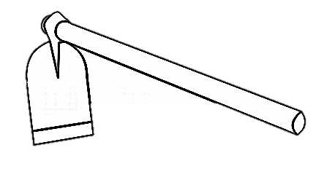

A

B

1. Identify the part marked A and B.
2. Hoe and wood
3. Handle and blade
4. Wood and metal
5. Blade and metal
6. Which of the following is a way of maintaining the implement.
7. Store it in wet room
8. Use it for digging
9. Keep it in dry place
10. Painting it
11. Which of the following is the major element of agricultural environment?
12. Manure
13. Light
14. Soil
15. Temperature
16. Which principal of farm business help the farmer to solve the problem of what and where to produce?
17. Substitution of input
18. Demand and supply
19. Comparative advantage
20. Farm enterprise
21. Identify the sign of maturity of guava fruits?
22. Fruit turns red
23. Seed shake inside the fruit
24. Fruit colour changes to light green
25. Fruit produces smell
26. The method of choosing good breed of cattle brought into the country for breeding is called?
27. Out breeding
28. Cross breeding
29. Selection
30. Introduction
31. When is the best time to prune an agroforestry plot 1.
32. When trees are young
33. When trees mature
34. At the beginning of second season
35. At the beginning of first season

*Study the indigenous farm machinery and technology below and use it to answer questions 18 and 19.*

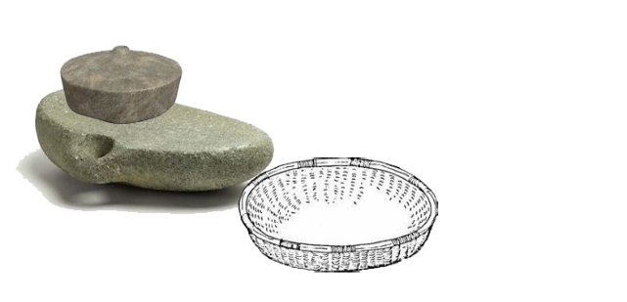

1. Identify the farm technology?
2. Winnower
3. Quern
4. Gourd
5. Leaf bag
6. State the function of the technology?
7. Storing grains
8. For winnowing
9. Grinding grains
10. Storing vegetables
11. The fish in the pond weight 100 kg what is daily amount of feed?
12. 1o kg
13. 20 kg
14. 2.5 kg
15. 5 kg

**SCIENCE**

1. Which of the following is the effect of taboo and beliefs?
2. High productivity every day
3. Stunted growth among children
4. Children grow well
5. Mother give birth to healthy baby
6. Which of the following part of flower develops into fruit after fertilisation
7. Petal
8. Ovule
9. Ovary
10. Stigma
11. Why is it advisable to wear black clothes on a cold day?
12. To look smart
13. To feel warm
14. To be seen a far
15. To feel cool
16. Why does a vacuum flask have a shinny inner surface?
17. To beautify the flask
18. To transfer heat
19. To strengthen the flask
20. To reduce loss of heat
21. Which of the following causes smothering?
22. Breathing in poisonous gases
23. Food entering the wind pipe
24. Covering head with plastic paper
25. Failing in water
26. Which of the following group of people are manual workers?
27. Brick moulder
28. House cleaner
29. Doctor
30. Manager
31. Which of the following way can improve sound transmitted by a string of telephone?
32. Lengthening the string
33. Making knots on the string
34. Loosening the string
35. Tightening
36. Which part of an ear directs sound into ear?
37. Ear drum
38. Ear cannal
39. Intier ear
40. Pinna
41. Which of the following food provide proteins into the body?
42. Oranges
43. White ants
44. Irish potatoes
45. Sugarcane
46. Which of the following can be dispersed by wind?
47. Guava
48. Coconut
49. Dandelion
50. Beans
51. State the organ that is responsible to control the transportation of food in the body?
52. Lung
53. Heart
54. Liver
55. Kidney
56. Which of the following sense organs controls the temperature?
57. Skin
58. Eye
59. Nose
60. Tongue

*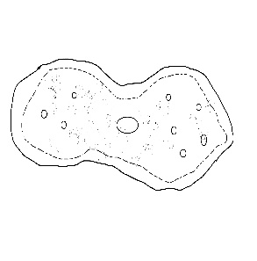Study the diagram below and use it to answer question 33-34.*

1. Name the invertebrate animal
2. Protozoa
3. Arthropod
4. Amoeba
5. Millipede
6. Which of the following ways of reproduction is used by the invertebrate above?
7. Cross breeding
8. Binary fusion
9. Sexually
10. Out breeding
11. The pull or push of an object is called __________?
12. Gravitation force
13. Magnetic force
14. Force
15. Electrostatic
16. Which of the following types of stems does Kapinga grass have?
17. Erect stem
18. Climbing stem
19. Creeping stem
20. Underground stem
21. Which of the following instrument produce sound by plucking?
22. Guitar
23. Whistle
24. Shaker
25. Drum
26. Why should starch be added to cotton garments in laundering?
27. To maintain shape
28. Maintain size
29. Maintain colour
30. Improve stiffness
31. What is the best way of knowing one’s self’s HIV status?
32. Counselling
33. HIV testing
34. Receiving ARV’s
35. Eating moringa(chammwamba)
36. Which of the following nutritional deficiency disease is caused by lack of iron in the diet?
37. Anaemia
38. Scurvy
39. Ricket
40. Goitre

**SECTION B**

AGRICULTURE

2. Define soil fertility?

_____________________________________________________________________ (1 mark)

1. List down two causes of soil fertility.

_________________________________________________________________________________________________________________________________________________ (2 marks)

1. What are the ways of controlling soil erosion?

_________________________________________________________________________________________________________________________________________________ (2 marks)

2. Why should farmers keep records of various farming activities? Give two.

_________________________________________________________________________________________________________________________________________________ (2 marks)

1. State one way of improving the availability of water for agriculture production.

________________________________________________________________________ (1 mark)

1. Why should water in bucket with fingerings be of the same temperature as that in the pond during stocking?

_________________________________________________________________________________________________________________________________________________ (2 marks)

2. Give two reasons why sand soil is not suitable for construction of a fish pond?

_________________________________________________________________________________________________________________________________________________ (2 marks)

1. Give any two importance of potassium for the plant growth and development?

_________________________________________________________________________________________________________________________________________________ (2 marks)

1. List the recommended method of applying fertilizer in rice farming?

____________________________________________________________________ (1 mark)

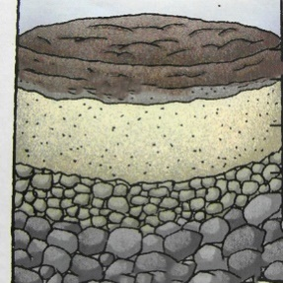***Figure 4*** *is an illustration showing soil profile. Use it to answer questions 44 A and B.*

A

B

C

D

2. Identify the part marked A.

_____________________________________________________________________ (1 mark)

1. Give two characteristics of part marked A.

_________________________________________________________________________________________________________________________________________________ (2 marks)

*Study the diagram of farm machinery. Use it to answer question 45* **a, b** *and* **c.**

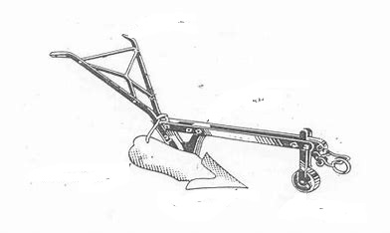

2. Name the farm implement

_____________________________________________________________________ (1 mark)

1. What is the use of part marked W?

_____________________________________________________________________ (1 mark)

1. Give any one safety measures when using the farm implement?

_____________________________________________________________________ (1 mark)

1. Mention two factors to consider when choosing a suitable site for growing flower?

_______________________________________________________________________________________________________________________________________________ (2 marks)

2. What is the difference between commercial farming and subsistence farming?

_________________________________________________________________________________________________________________________________________________ (2 marks)

1. Why should a vegetative garden be near school or home, give two.

_________________________________________________________________________________________________________________________________________________ (2 marks)

1. Give any two types of soil structure.

_________________________________________________________________________________________________________________________________________________ (2 marks)

1. Give any one characteristics of fish suitable for farming.

_____________________________________________________________________ (1 mark)

**SCIENCE**

2. Mention any two groups of invertebrate animals.

_________________________________________________________________________________________________________________________________________________ (2 marks)

1. Give any two importance of invertebrate’s animals?

_________________________________________________________________________________________________________________________________________________ (2 marks)

1. State one technology for conserving the environment.

_____________________________________________________________________ (1 mark)

2. Explain the advantage of boiling method over baking method.

_________________________________________________________________________________________________________________________________________________ (2 marks)

1. State two importance of under-five clinic?

____________________________________________________________________ (2 marks)

1. State the two family planning methods used by males?

_________________________________________________________________________________________________________________________________________________ (2 marks)

2. Mention two classes of lever as a machinery.

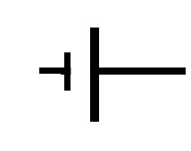_________________________________________________________________________________________________________________________________________________ (2 marks)

1. What does the following symbols in a cell represent
2. A short line: _________________________________
3. A long line: __________________________________ a cell (2 marks)
4. Mention two types of circuits.

_________________________________________________________________________________________________________________________________________________ (2 marks)

2. State two properties of gases.

_________________________________________________________________________________________________________________________________________________ (2 marks)

1. What is a solvent?

_____________________________________________________________________ (1 mark)

1. Give any two problems of digestion?

_________________________________________________________________________________________________________________________________________________ (2 marks)

2. Define a food chain?

____________________________________________________________________ (1 mark)

1. What is the function of pupil of an eye?

____________________________________________________________________ (1 mark)

1. Animals without skeleton moves in different ways, give any one?

____________________________________________________________________ (1 mark)

1. Why is rain water ideal for laundering?

____________________________________________________________________ (1 mark)

2. Mention two ways of preserving food?

_________________________________________________________________________________________________________________________________________________ (2 marks)

1. State any one characteristics of amphibians?

_____________________________________________________________________ (1 mark)

**END OF QUESTION PAPER**