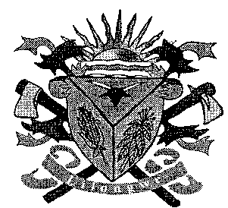**THE LILONGWE URBAN DISTRICT EXAMINATION BOARD**

**2023 END OF THIRD TERM EXAMINATIONS FOR STD 6**

**SOCIAL STUDIES /RELIGIOUS EDUCATION AND BIBLE KNOWLEDGE**

**(100 Marks)**

**Time allowed: ……………**

**Date: ……./…../…….**

**NAME OF CANDIDATE: ________________________________________________________________**

**(Surname first)**

**NAME OF SCHOOL: ___________________________________________________________________**

**INSTRUCTIONS**

1. This paper contains **6 Pages.** Please check
2. This paper has three sections A, B and C
3. Section A has **30** multiple questions and section B and C and structured questions
4. In section B or C write your answer in the spaces provided

**IMPORTANT**

1. Make sure you have written your **name** and **school name** on the question paper in the spaces provided.
2. Please hand in your filled-in question paper to the invigilator at the end of the examination.

**SECTION A (30MARKS)**

**SOCIAL AND ENVIRONMENTAL SCIENCES**

1. Which of the following is the head of city assembly
   1. Mayor C. Lawyer
   2. Councilor D. Pilot
2. Name the district which your school is located
   1. Ntcheu C. Lilongwe
   2. Mulanje D. Chitipa
3. Malawi is a land locked country because
   1. It is surrounded by rivers
   2. It is surrounded by lakes
   3. It is surrounded by Dzalanyama
   4. It is surrounded by other countries
4. The following are the major physical features except
   1. Highlands C. Lowlands
   2. House D. Lakes
5. Which country share boundary with Malawi to the North
   1. Tanzania C. South Africa
   2. Zambia D. Mozambique
6. Who was the founder of Mwenemutaoa kingdom?
   1. Zwangendaba
   2. Chikulamayembe
   3. Nyatsimba Mutota
   4. Tchaka Zulu
7. Who is the current vice – president of Malawi?
   1. Bakili Muluzi
   2. Dr Joyce Banda
   3. Peter Munthalika
   4. Saulosi Chilima
8. Which of the following is a forest reserve in Malawi?
   1. Chitipa forest reserve
   2. Dzalanyama forest reserve
   3. Lilongwe forest reserve
   4. Nsanje forest reserve
9. Define population density?
   1. Number of people living per unit area
   2. Number of people at a school
   3. Number of people in a country
   4. Number of people in a district
10. How does a person acquire citizenship in Malawi?
    1. Migration C. By birth
    2. Justice D. Councilor

**Figure I shows social service in Malawi. Use it to answer question 11 and 12**

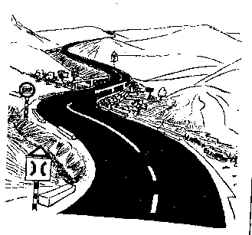

1. Name the social service
   1. Bank C. School
   2. Hospital D. Road
2. Which service does the above social service provides?
   1. Health services
   2. Transporting services
   3. Educating services
   4. Banking services
3. What does the word Chikulayambe mean?
   1. Carrier of hoes
   2. Leader of Malavi
   3. The fall of nkhamanga kingdom
   4. Carrier of axes
4. Why is tourism important in Malawi?
   1. Source of food
   2. Source of minerals
   3. Source of foreign exchange
   4. Source of land
5. Mention any two causes of drug and substance abuse
   1. Infertility and overdose
   2. Headache and smoking
   3. Drug and substance
   4. Peer pressure and curiosity
6. Which of the following districts is named after mountains
   1. Ntchisi C. Lilongwe
   2. Mulanje D. Nkhotakota

**Figure 2 shows cardinal points. Use it to answer question 17 and 18**

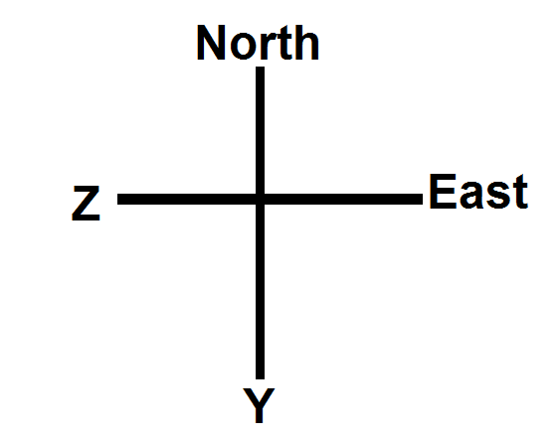

1. Identify the cardinal point marked X
   1. West C. East
   2. South D. West
2. What is the use of cardinal points?
   1. To go to school
   2. To predict weather
   3. To locate direction
   4. To tell the time
3. Define soil erosion?
   1. The exchange of gas
   2. The application of manure
   3. The removal of top soil
   4. The removal of unwanted plants
4. Which of the following is a way of preventing HIV and AIDS
   1. Having protected sex
   2. Sharing sharp objects
   3. Cultural practices
   4. Abstinence
5. A ____ is any substance used for medical purpose
   1. Abuse C. Substance
   2. Drug D. Glue
6. Which of the following methods of fishing are used in Malawi
   1. Fish traps and gill net
   2. Mono and breeding
   3. Overfishing
   4. Trawl net and plants
7. List any two elements of weather
   1. Rainfall and soil
   2. Temperature and water
   3. Trees and bridges
   4. Rainfall and humidity
8. Which of the following is a mean of communication?
   1. Motor vehicles
   2. Bicycles
   3. Faxes
   4. Trains
9. Which of the following types of climate does Malawi experience?
   1. Tropical Savannah climate
   2. Monsoon climate
   3. Equatorial climate
   4. Mediterranean climate
10. Mention any two tourism centres in Malawi
    1. Water and soil
    2. Stadium and lakes
    3. Banks and hotels
    4. Lakes and national parks
11. Which of the following are the types of farming in Malawi
    1. Irrigation and subsistence
    2. Commercial and subsistence
    3. Fish and commercial
    4. Chicken and maize farming
12. Which of the following refers to all things that surrounds us
    1. Culture C. Religion
    2. Environment D. Land
13. ____ refers to equal treatment of males and females
    1. Gender role
    2. Gender inequality
    3. Gender equality
    4. Gender stereotype
14. Which of the following is the biggest river in Malawi?
    1. Shire river C. Songwe river
    2. Zambezi river D. Bua river

**SECTION B (35MARKS)**

1. (a) Define the term physical features

____________________________________________________________________________1mark

(b) Give three examples of physical features

1. ______________________________________________________________________________
2. ______________________________________________________________________________
3. ________________________________________________________________________3marks

(c) Why are physical features important? Give three reasons

1. ______________________________________________________________________________
2. ______________________________________________________________________________
3. ________________________________________________________________________3marks
4. (a) Mention two factors that led to the growth of the Ngoni kingdom
5. ______________________________________________________________________________
6. ________________________________________________________________________2marks

(b) State two ways of preventing the spread of HIV and AIDS

1. ______________________________________________________________________________
2. ________________________________________________________________________2marks

(c)Mention any three contributions of the Ngoni kingdom

1. ______________________________________________________________________________
2. ______________________________________________________________________________
3. ________________________________________________________________________3marks
4. (a) In which regions are the following districts
5. Rumphi __________________________________________________________________1mark
6. Balaka ___________________________________________________________________1mark

(b) Name the earliest settlers of Malawi

____________________________________________________________________________1mark

(c) State any two misconception about HIV and AIDS

1. ______________________________________________________________________________
2. ________________________________________________________________________2marks

(d) List down any two people who showed patriotism/ bravery in Malawi

1. ______________________________________________________________________________
2. ________________________________________________________________________2marks

**Figure 3 is a diagram of an instrument of weather. Use it to answer questions 34a and b**

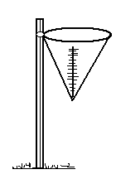

1. (a) Name the instrument

____________________________________________________________________________1mark

(b) What is the use of an instrument?

____________________________________________________________________________1mark

(c) Describe any two effects of drug and substance abuse

1. ______________________________________________________________________________
2. ________________________________________________________________________2marks

(d) Mention the three components of environment

1. ______________________________________________________________________________
2. ______________________________________________________________________________
3. ________________________________________________________________________3marks
4. (a) State any two organizations that help to check the abuse of power
5. ______________________________________________________________________________
6. ________________________________________________________________________2marks

(b) State two city assemblies in Malawi

1. ______________________________________________________________________________
2. ________________________________________________________________________2marks

(c) Name one advantage of each of the following

1. Car ___________________________________________________________________________
2. Bicycle _______________________________________________________________________
3. Letter ___________________________________________________________________3marks

**SECTION C (35MARKS)**

**PART I : BIBLE KNOWLEDGE**

1. (a) Who was the mother of Jesus Christ?

____________________________________________________________________________1mark

(b) Mention two types of food provided to the Hebrews in the deserts

1. ______________________________________________________________________________
2. ________________________________________________________________________2marks

(c) Mention two animals which were used during the Passover

1. ______________________________________________________________________________
2. ________________________________________________________________________2marks

(d) Why did Hebrews double their normal quantity of food in the sixth day?

____________________________________________________________________________________________________________________________________________________________2marks

1. (a) Define the following terms
2. Exodus __________________________________________________________________1mark
3. Passover _________________________________________________________________1mark

(b) Who was Jacob’s daughter?

____________________________________________________________________________1mark

(c) Why did Jacob moved to Egypt

____________________________________________________________________________1mark

(d) Explain why the disciples thought that Jesus was a ghost

____________________________________________________________________________________________________________________________________________________________2marks

(e) Who betrayed Jesus?

____________________________________________________________________________1mark

1. (a) What are the three ways of resolving conflict peacefully
2. ______________________________________________________________________________
3. ______________________________________________________________________________
4. ________________________________________________________________________3marks

(b) Explain how God called Moses

____________________________________________________________________________________________________________________________________________________________2marks

(c) How long did Lazarus stay in the grave?

____________________________________________________________________________1mark

(d) Define conflict

____________________________________________________________________________1mark

1. (a)What type of food did Jesus use to feed give thousand people
2. ______________________________________________________________________________
3. ________________________________________________________________________2marks

(b) Mention any two examples of vulnerable children

1. ______________________________________________________________________________
2. ________________________________________________________________________2marks

(c) State two miracles that Jesus performed over death

1. ______________________________________________________________________________
2. ________________________________________________________________________2marks

(d) What is death?

____________________________________________________________________________1mark

1. (a) State any two duties of Jesus followers
2. ______________________________________________________________________________
3. ________________________________________________________________________2marks

(b) Why was Joseph hated by his brothers?

1. ______________________________________________________________________________
2. ________________________________________________________________________2marks

(c) State any two rights of children

1. ______________________________________________________________________________
2. ________________________________________________________________________2marks

(d) Define the term Ark of covenant

____________________________________________________________________________1mark

**PART 2 : RELIGIOUS EDUCATION (35MARKS)**

1. (a) Mention the three common religions in Malawi
2. ______________________________________________________________________________
3. ______________________________________________________________________________
4. ________________________________________________________________________3marks

(b) Name any two occasions where rituals are performed in Malawi

1. ______________________________________________________________________________
2. ________________________________________________________________________2marks

(c) Why are rituals important? Give two reasons

1. ______________________________________________________________________________
2. ________________________________________________________________________2marks
3. (a) Who created heaven and earth

____________________________________________________________________________1mark

(b) Trinity means ________________________________and ____________________________3marks

(c) Draw one artifact in Christianity and name it

2marks

(d) Give one way of honouring God

____________________________________________________________________________1mark

1. (a) What do the following terms mean
2. Virtues ________________________________________________________________________
3. Tawhid __________________________________________________________________2marks

(b) State any two local ways of sending and receiving messages

1. ______________________________________________________________________________
2. ________________________________________________________________________2marks

(c)Explain two ways of caring for the environment

1. ______________________________________________________________________________
2. ________________________________________________________________________2marks

(d) What does word Mufti in Islam mean?

____________________________________________________________________________1mark

1. (a) Mention any two commandments in the Bible that you know
2. ______________________________________________________________________________
3. ________________________________________________________________________2marks

(b) Describe any two ways how religious groups assist people with HIV and AIDS

1. ______________________________________________________________________________
2. ________________________________________________________________________2marks

(c) What is the use of water in the following religions?

1. Christianity ____________________________________________________________________
2. Islam ___________________________________________________________________2marks

(d) How can we prevent the spread of HIV and AIDS?

____________________________________________________________________________1mark

1. (a) Who were the founders of the following religions
2. Islam _________________________________________________________________________
3. Christianity ____________________________________________________________________
4. ATR____________________________________________________________________3marks

(b) What did Jesus used soil for in the Bible?

____________________________________________________________________________1mark

(c) Name any three things created by God

1. ______________________________________________________________________________
2. ______________________________________________________________________________
3. ________________________________________________________________________2marks

**END OF QUESTION PAPER**