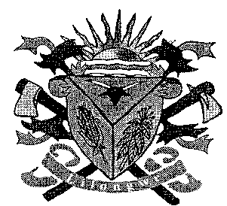**THE LILONGWE URBAN DISTRICT EXAMINATION BOARD**

**2023 END OF THIRD TERM EXAMINATIONS FOR STD 7**

**EXPRESSIVE ARTS**

**(100 Marks)**

**Time allowed: ……………**

**Date: ……./…../…….**

**NAME OF CANDIDATE: ________________________________________________________________**

**(Surname first)**

**NAME OF SCHOOL: ___________________________________________________________________**

**INSTRUCTIONS**

* This paper contains **5 pages**. Please check

Answer **all** questions.

* This paper has **two** sections **A** **B and C.**
* Follow instructions for each section carefully.
* In the table provided on this page, **tick** against the question number you have answered

**IMPORTANT**

* Make sure you have written your **name** and **school name** on the question paper in the spaces provided.
* Please hand in your filled-in question paper to the invigilator at the end of the examination

|  |  |  |  |
| --- | --- | --- | --- |
| **Question number** | **Tick question if answered** | **Do not write in these columns** | |
| 1- 30 |  |  |  |
| 31 |  |  |  |
| 32 |  |  |  |
| 33 |  |  |  |
| 34 |  |  |  |
| 35 |  |  |  |
| 36 |  |  |  |
| 37 |  |  |  |
| 38 |  |  |  |
| 39 |  |  |  |
|  | |  |  |
|  |  |

**SECTION A**

**EXPRESSIVE ARTS**

1. Which of the following artistic works contribute to the destruction of environment
2. Carving iii. Knitting
3. Sewing iv. Modelling
   1. i and ii C. ii and iv
   2. i and iv D. i and ii
4. Who is allowed to use both legs and hands when playing football game?
   1. Coach C. Referee
   2. Defender D. Goal keeper

**Figure I below is a musical instrument. Use it to answer question below**

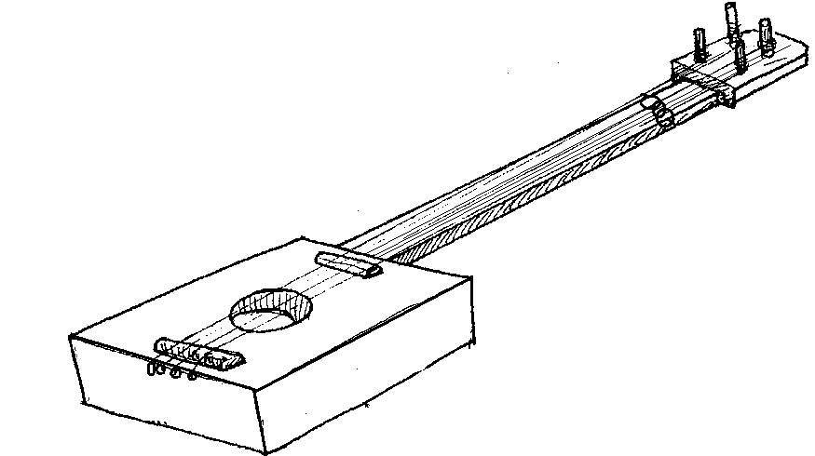

1. How does this musical instrument produce sound?
   1. Beating hard
   2. Plucking vigorously
   3. Blowing continuously
   4. Tightening the strings
2. What name is given to men who perform drama?
   1. Actress C. Characters
   2. Actors D. Plot
3. Why do people wear sports attire when doing physical education ?
   1. To please others
   2. To run fast
   3. To gain power
   4. To ass beauty to the performance
4. Describe any two activities that will make you move at different height levels
   1. Sleeping and jumping
   2. Jumping and standing still
   3. Jumping and running
   4. Running and sleeping

**Figure 2 shows artistic activities. Study it and answer the questions below**

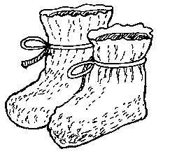

1. Name the item
   1. Baby bot C. Baby bonnet
   2. Baby hat D. Baby shoes
2. Mention one artistic which requires working together with others when performing
   1. Fighting C. Crying
   2. Dancing D. Writing
3. The following are importance of traditional dances except
   1. Identity C. Entertainment
   2. Unity D. Gesturing
4. State one way of making pictures for sale more attractive
   1. Painting C. making mats
   2. Carving D. Animals

**LIFE SKILLS**

1. Identify one common basic human rights
   1. Discrimination
   2. Life
   3. Violence
   4. Death
2. Identify the cause of conflicts
   1. Dancing C. Eating
   2. Stealing D. Wearing shoes
3. When friend or classmates force you to do something is called
   1. Goal
   2. Adolescence
   3. Peer pressure
   4. Drug and substance abuse
4. Adolescence is a person between the ages of
   1. 6 – 14 C. 9 – 19
   2. 10 – 18 ` D. 18 – 24
5. State two qualities of home based care providers
   1. Kindness and conflict
   2. Patience and kindness
   3. Guidance and provision
   4. Tolerance and food
6. The following are situations that can change plans except
   1. Farming
   2. Death
   3. Illness
   4. In availability of resources
7. Which of the following is a barrier to HIV testing and counseling
   1. Client undergoes post test
   2. Lack of confidentiality
   3. Client sample is missing
   4. Client is told to test results
8. Mention the needs of the less privileged?
   1. Songs and medicine
   2. Spiritual support and children
   3. Clothes and food
   4. Songs and dance
9. What could drugs and substance abuse lead to
   1. Fashionable C. Thinking
   2. Intelligent D. Mental disorder
10. Which of the following is the first source of information on sex and sexuality for the youth
    1. Parents C. Community
    2. Religion D. Peers
11. Which of the following is the common sexual transmitted infection
    1. Diarrhoea C. Syphilis
    2. Cholera D. Tuberculosis
12. Which of the following sex role is for females?
    1. Impregnating
    2. Child bearing
    3. Child upbringing
    4. Attending the six

**CASE STUDY**

**Read the case study below and answer questions that follows**

When Chikondi reached puberty, her father saw a need for her to be initiated while the mother insisted on sending the girl home for initiation

1. Which of the following was the source of conflict between the parents
   1. Social status
   2. Cultural difference
   3. Age differences
   4. Education attainment
2. Which of the following ways can Chikondi’s parents use to resolve the conflict?
   1. Self-awareness
   2. Coping with emotions
   3. Negotiations
   4. Entrepreneurship

**Figure below shows some steps of the planning process. Use it to answer questions that follow**

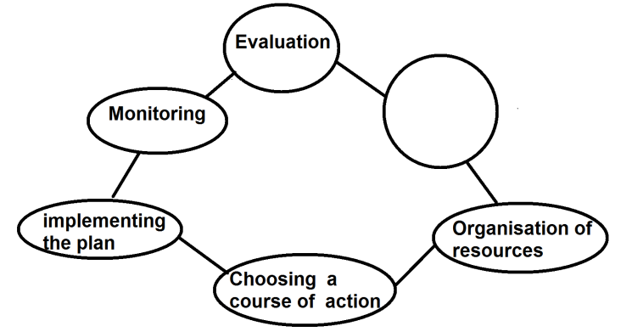

1. Name the process labeled 1
   1. Evaluation
   2. No goal
   3. Identifying goal
   4. Lack of resource
2. Identify the three types of bathrooms
   1. Water closer, shower and shelter
   2. Basin, bathtub and shower
   3. Flower beds, sink and shelter
   4. Shower , bathtubs and shelter
3. What do we call the receiving and sending of information from one point to another in a clear manner
   1. Interpersonal relationship
   2. Channels of communication
   3. Effective communication
   4. Effects of communication
4. One of the situation that require decision making and problem solving skills is
   1. Love and care
   2. Assertiveness
   3. Physical body changes
   4. Effective communication
5. Which of the following conflict resolution does not involve a third person?
   1. Arbitration C. Mediation
   2. Negotiation D. Arbitrator
6. Which of the following is a term refers to substance that may be used for medical purpose
   1. Substance
   2. Drug
   3. Counseling
   4. Sexual transmitted infections

**SECTION B**

**EXPRESSIVE ARTS (30MARKS)**

1. (a) Give two activities that make the body to move at different height levels
2. ______________________________________________________________________________
3. ________________________________________________________________________2marks

(b) State two importance of body movement

1. ______________________________________________________________________________
2. ________________________________________________________________________2marks

(c) Give any two components of general space

1. ______________________________________________________________________________
2. ________________________________________________________________________2marks

(d) Define time signature

___________________________________________________________________________2marks

(e) Explain two importance of general and personal space

1. ______________________________________________________________________________
2. ________________________________________________________________________2marks

**Figure 3 is a diagram showing an artistic item study and answer questions below**



1. (a) Name artistic item

____________________________________________________________________________1mark

(b) State any two tools used to make the artistic item

1. ______________________________________________________________________________
2. ________________________________________________________________________2marks

(c) What message is communicated by a cock when it crows?

____________________________________________________________________________1mark

(d) What does white colour symbolizes in Malawi?

____________________________________________________________________________1mark

1. (a) Give two importance of taking body measurements
2. ______________________________________________________________________________
3. ________________________________________________________________________4marks

(b) Mention two types of dram

1. ______________________________________________________________________________
2. ________________________________________________________________________2marks

(c) Mention two sources of risks in sewing

1. ______________________________________________________________________________
2. ________________________________________________________________________2marks
3. (a) Mention the tribe which perform the following traditional dances
4. Gule wamkulu _____________________________________________________________1mark
5. Ingoma __________________________________________________________________1mark
6. Vimbuza _________________________________________________________________1mark

(b) Mention any three foreign dances

1. ______________________________________________________________________________
2. ________________________________________________________________________2marks

(c) Write the mostly used time signature in music

____________________________________________________________________________1mark

1. (a) Mention two ways of disposing wastes
2. ______________________________________________________________________________
3. ________________________________________________________________________2marks

(b) List down any two cultural practices that affect good health habit

1. ______________________________________________________________________________
2. ________________________________________________________________________2marks

(c) Explain two misconceptions which may make people abuse drugs and substances

1. ______________________________________________________________________________
2. ________________________________________________________________________2marks

(d) Give two ways of managing stress and anxiety

1. ______________________________________________________________________________
2. ________________________________________________________________________2marks

**CASE STUDY**

1. Read the case study below and use it questions a and b

Tinyade is a standard 7 learner at Mwatibu Primary School. Her father always tell her to stop going to school and join her at the farm. Tinyade dropped out of school because she was looking motivation.

1. Which human rights were violated by Tinyade?

____________________________________________________________________________________________________________________________________________________________2marks

1. Which skill could Tinyade have used to cope with the problem or pressure from her father

____________________________________________________________________________________________________________________________________________________________2marks

(c).Give two physical changes which boys and girls experiences as they grow up

1. ______________________________________________________________________________
2. ________________________________________________________________________2marks
3. (a) Who are less privileged people?

____________________________________________________________________________________________________________________________________________________________2marks

(b).Identify two examples of less privileged people

1. ______________________________________________________________________________
2. ________________________________________________________________________2marks

(c).What are the impacts of stigmatizing the less privileged people in a society (give two)

1. ______________________________________________________________________________
2. ________________________________________________________________________2marks

(d).State one consequence of sexual relationships

1. _________________________________________________________________________1mark
2. (a) Why are more females infected and affected by HIV and AIDS than males. Give two
3. ______________________________________________________________________________
4. ________________________________________________________________________2marks

(b).Mention any two types of relationships

1. ______________________________________________________________________________
2. ________________________________________________________________________2marks

(c).Identify two challenges that the youth face in everyday life

1. ______________________________________________________________________________
2. ________________________________________________________________________2marks
3. (a) Suggest any two misinformation about sex and sexuality
4. ______________________________________________________________________________
5. ________________________________________________________________________2marks

(b)Mention two ways of overcoming barriers to effective communication on HIV and AIDS

1. ______________________________________________________________________________
2. ________________________________________________________________________2marks

(c). Mention two problems associated with HIV and AIDS

1. ______________________________________________________________________________
2. ________________________________________________________________________2marks

(d).Mention one factor that help to improve communication on HIV and AIDS

1. _________________________________________________________________________1mark

(e)Define the term gender equity?

____________________________________________________________________________1mark

1. (a) Explain any two situations that require planning
2. ______________________________________________________________________________
3. ________________________________________________________________________2marks

(b)Give any two situations that require planning

1. ______________________________________________________________________________
2. ________________________________________________________________________2marks

(c).What are two effects of leaving in contaminated environment

1. ______________________________________________________________________________
2. ________________________________________________________________________2marks

**END OF QUESTION PAPER**