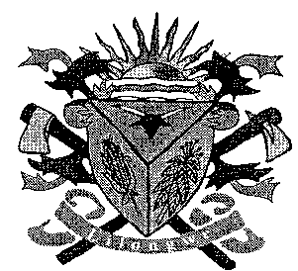**THE LILONGWE URBAN DISTRICT EXAMINATION BOARD**

**2023 END OF THIRD TERM EXAMINATIONS FOR STD 6**

**MATHEMATICS**

**(100 Marks)**

**Time allowed: ……………**

**Date: ……./…../…….**

**NAME OF CANDIDATE: ________________________________________________________________**

**(Surname first)**

**NAME OF SCHOOL: ___________________________________________________________________**

**INSTRUCTIONS**

* This paper contains **6 pages**. Please check
* Answer **all** questions.
* Encircle the letter corresponding to the right answer to each question
* This paper has **two** sections **A** **and B.**
* Follow instructions for each section carefully.

**IMPORTANT**

* Make sure you have written your **name** and **school name** on the question paper in the spaces provided.
* Please hand in your filled-in question paper to the invigilator at the end of the examination

**SECTION A (40MARKS)**

1. Write one million two hundred ninety four thousand and twenty four
   1. 1 224 024 C. 1 294 024
   2. 1324 024 D. 1 284 ,024
2. Find the LCM of 4, 6 and 8
   1. 23 C. 22
   2. 20 D. 24
3. Change the mixed fraction to be improper fraction:
   1. C.
   2. D.
4. Simplify 8: 12 to its lowest term
   1. 1:2 C. 2:3
   2. 3:4 D. 3:8
5. 0. 341

+ 0. 260

* 1. 0.501 C. 0.606
  2. 0.701 D. 0.601

1. 0.32 ÷8
   1. 0.05 C. 0.6
   2. 0.04 D. 0.4
2. Change 56.8 to the nearest whole number
   1. 59 C. 58
   2. 57 D. 59.5

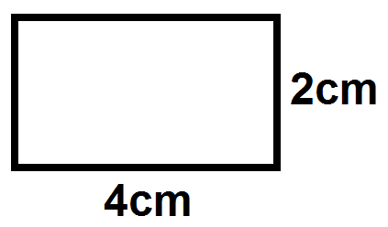



What name is given to the above shape

* 1. Triangle C. Rectangle
  2. Square D. Circle

1. ℓ mℓ

269 55

× 5

* 1. 1345ℓ 275mℓ
  2. 1245ℓ 265mℓ
  3. 1445ℓ 278mℓ
  4. 1748ℓ 378mℓ

1. Find the sum of 1280506, 2072936, 123, 284, 2750 283 and 2378943
   1. 10705953 C. 11, 605 953
   2. 8 605 952 D. 8, 705 695
2. Find the area of a triangle which has a base of 4cm and height of 5cm
   1. 30cm2 C. 15cm2
   2. 20cm2 D. 10cm2
3. What is the missing number in the following number patterns?

12, 36, 108 _____

* 1. 72 C. 324
  2. 144 D. 288

**For question 13 and 14 use table 1 shows learners marks represented by tallies**

|  |  |
| --- | --- |
| **Learners** | **Marks %** |
| Rhoda |  |
| Elina |  |
| Zione |  |

1. Find the total marks scored by Zione
   1. 18 C. 15
   2. 17 D. 22
2. Which learner scored 18%
   1. Zione C. Rhoda
   2. Elina D. Mphatso
3. From the inequality from the following:

Y minus 9 is less than 0

* 1. Y + 9 = 10 C. Y – 9 < 10
  2. Y – 9 > 10 D. Y + 10 > 9

1. Find the volume of cuboids below

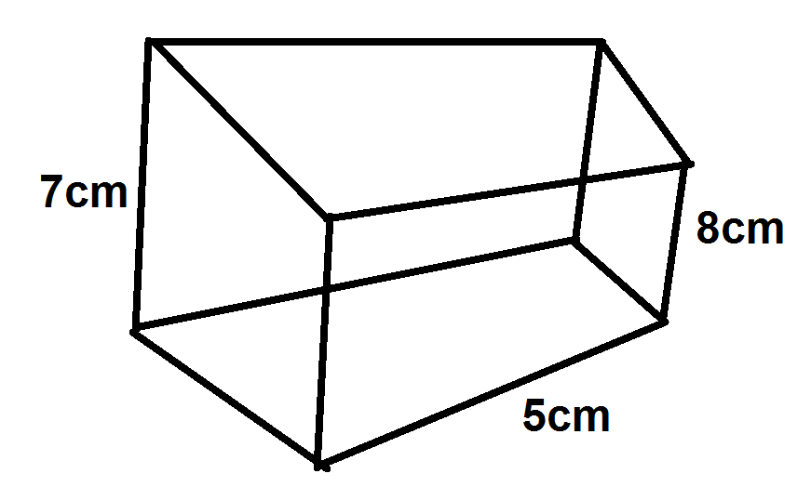

* 1. 275cm3 C. 260cm3
  2. 200cm3 D. 280cm3

1. Simplify the following ratio to their simplest form:

1

* 1. 3:4 C. 2:3
  2. 3:5 D. 5:7

1. A bicycle costs K6 890 what is the cost of 23 bicycle
   1. K582450 C. K158 470
   2. K580 482 D. K1,058 478
2. Change to mixed fraction
   1. 2 C. 4
   2. 3 D. 6
3. Tell the following time

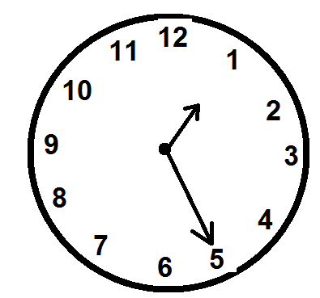

* 1. 25minutes past 3
  2. 25minutes to 3
  3. 25 minutes past 1
  4. 26minutes past 2

**SECTION B (60MARKS)**

1. (a) Find the perimeter of the figure below

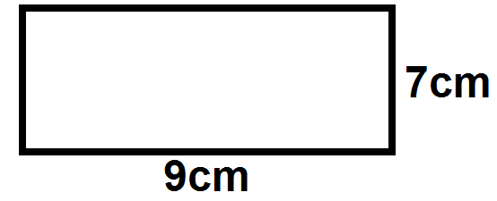

3marks

(b) Simplify 3

3marks

1. (a) Mrs Phiri bought the following items:

6 packets of sugar at K1550 each

4 bunches of rape at K5.00 each

5 books at K25.00 each

Prepare the bill

5marks

(b) How much change did he receive from K10, 000?

2marks

1. Take away K28642.99 from K42322.00

2marks

1. (a)

3marks

(b) Km m cm

5 210 15

7 975 82

+ 12 126 63

5marks

1. In standard 6 there are 60 girls and 40 boys
2. What is the ratio of the number girls to the number of boys?

3marks

1. What is the ratio of the number boys to number of girls

3marks

1. Copy and complete the following table

|  |  |  |
| --- | --- | --- |
| **K t** | **K** | **Tambala** |
| 183 40 | 183.40 | 18 340 |
| __________ | __________ | 7983 |
| _______________ | 908.56 | ______________ |
| 8924 38 | 8924.38 | ________________ |

5marks

1. Simplify: 1 to its lowest term

4marks



7 861ℓ 840mℓ

5marks

1. (a) Simplify 7 3

4marks

(b) Find the HCF of 20 and 104 using continued division method

5marks

1. The number of tree in 5 zones of a certain district were as follows

Using a scale of 1:20 draw a picture graph to show this information

|  |  |
| --- | --- |
| **Zone** | **Number of trees** |
| Dzobwe | 200 |
| Menyani | 240 |
| Lemekezani | 180 |
| Temwani | 220 |
| Sinde | 280 |

8marks

**END OF QUESTION PAPER**