**CHIGUMUKIRE ZONE EXAMINATIONS BOARD**

**2025 PRIMARY SCHOOL LEAVING CERTIFICATE MOCK EXAMINATIONS**

**SOCIAL AND RELIGIOUS STUDIES**

(100 Marks)

**Time Allowed: 1 Hours**

**01:00 – 02:30 pm**

**Date: ……………… 2025**

**NAME OF CANDIDATE : ___________________________________________________________________**

(Surname First)

**SCHOOL NAME : ___________________________________________________________________**

|  |  |  |  |  |  |  |  |
| --- | --- | --- | --- | --- | --- | --- | --- |
| **Question Number** | **Tick If Answered** | **Do not write in these columns** | | | | | |
| **1 – 30** |  |  | |  | |
| **31** |  |  | |  | |
| **32** |  |  | |  | |
| **33** |  |  | |  | |
| **34** |  |  | |  | |
| **35** |  |  | |  | |
| **36** |  |  | |  | |
| **37** |  |  | |  | |
| **38** |  |  | |  | |
| **39** |  |  | |  | |
| **40** |  |  | |  | |
| **41** |  |  | |  | |
|  | | |  | |  | |

**Instructions**

1. **This paper consists of 6 printed pages. Please check**
2. Write your name and name of your school in the Spaces provided
3. This paper consists of two sections A and B
4. In section A encircle the letter **A, B, C or D** that represents the write answer for each question. In section B write your answers in the spaces provided
5. Write all your answers to the questions in both Sections
6. In the table provided on this page, tick against The question number you have answered.
7. Hand in your worked paper to the invigilator when time is called to stop writing

**IMPORTANT**

1. Make sure you have written your name, school
2. Name and examination number on the question

paper in the spaces provided in the spaces Provided.

**SECTION A**

**Multiple Choice** (30 marks)

* Encircle the letter A, B, C or D that best represent the right answer to the question

**SOCIAL STUDIES**

1. Which of the following describes the desert vegetation?
   1. Vegetation is always green
   2. Grass regenerates when the rain comes
   3. Vegetation has waxy leaves and thorns
   4. Grass is tall and cover many areas
2. Which of the following physical features is a highland with flat top?
   1. Plateoux C. Mountains
   2. Rift valley D. Plains
3. Which of the following is type of word climate that has no summers?
   1. Equatorial climate
   2. Tropical monsoon climate
   3. Tropical desert climate
   4. Tundra climate
4. Which of the following organisations deals with HIV and AIDS?
   1. United Nations High Commission for Refugees (UNHCR)
   2. Ant-Corruption Bureau (ACB)
   3. National Road Safety Council of Malawi (NRSCM)
   4. Adventist Development Relief Agency (ADRA)
5. Kalikokha is a shoe repair. To which type of work does the work done by kalikokha belong?
   1. Paid work C. Voluntary work
   2. Wage labour D. Self employed
6. The type of budget that can be done by the grain and milling company is called ________
   1. Personal budget C. Stage budget
   2. Industrial budget D. Institutional budget
7. Which of the following people were looking for grazing land and water for their livestock?
   1. The Ngoni C. The Tonga
   2. The Chewa D. The Yao

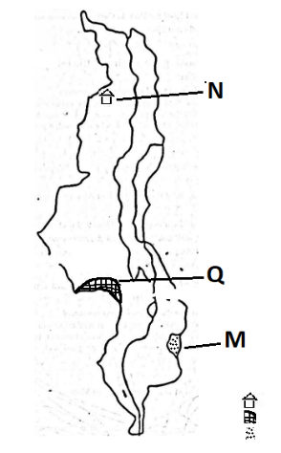**Figure 1 is a map of Malawi. Use it to answer questions 7, 8 and 9.**

**Key**

National Park

Forest Reserve

Climate



1. Which of the following type of climate is found in area marked **M**?
   1. Cool-Wet C. Hot-Wet
   2. Warm-wet D. Hot and dry
2. Identify national park marked **N.**
   1. Kasungu C. Nyika
   2. Lengwe D. Liwonde
3. What is the name of the forest reserve marked **Q**?
   1. Dedza C. Chongoni
   2. Mchinji D. Dzalanyama
4. Which of the following would improve if people are paying taxes accordingly?
5. Teaching
6. Vending
7. Smuggling
8. Health
   1. 1 and 2 C. 2 and 3
   2. 1 and 4 D. 3 and 4
9. What name is given to the path through which the earth goes around the sun?
   1. Axis C. Rotation
   2. Revolution D. Orbit
10. One factor that led to the decline of Egyptian civilization.
    1. The attacks by the Greeks
    2. The invasion by the Europeans
    3. The prosperous trade in gold
    4. Internal conflict
11. What do we call the term of having same status right and responsibilities for both men and women?
    1. Gender equality
    2. Gender equity
    3. Gender inequality
    4. Gender stereotype
12. Socio-economic instructions are organisations that _______________
    1. Benefit on funds
    2. Provide funds
    3. Refund funds
    4. Do not provide funds
13. Which of the following is the head of the constituency?
    1. Councilor
    2. Mayor
    3. President
    4. Member of parliament
14. In which district does limestones mining take place in Malawi?
    1. Karonga and Rumphi
    2. Kasungu and Karonga
    3. Balaka and Rumphi
    4. Kasungu and Balaka
15. Where is the headquarters of United Nation organization?
    1. New York C. Brussels
    2. Addis Ababa D. Paris
16. Which of the following is the highest court in Malawi?
    1. The traditional court
    2. The supreme court
    3. The high court
    4. The magistrate court
17. Which of the following was the negative effect of partition of Africa?
    1. Introduction of European education
    2. Division of ethnic groups
    3. Abolishment of dictatorship
    4. Introduction of cash crops
18. By registering at the poling centre a person is exercising a right to _________________
    1. Education C. Life
    2. Employment D. Voter
19. The state of atmosphere for a place for a short period of time is called _________________
    1. Air pressure C. Weather
    2. Humidity D. Climate
20. Which of the following is the importance of the road signs?
    1. To beautify the roads
    2. To be used as teaching materials
    3. To show distances between places
    4. To shorten distances between places
21. For which of the following was Sparta farming?
    1. Trade
    2. Learning
    3. Being a port city
    4. Being a military state
22. Which of the following crop is grown for subsistence farming
    1. Tobacco C. Tea
    2. Rice D. Coffee
23. Which of the following terms mean money paid monthly to an insurance company?
    1. Endowment C. Premium
    2. Policy C. Contract
24. Which of the following is the advantages of nuclear family?
    1. Good standard of living family
    2. Freedom from problems of relatives
    3. Protection from danger from relatives
    4. The family being able to help both mother and fathers’ families
25. Through which of the following does person acquire citizenship in Malawi?
    1. By voting C. By being riyal
    2. By birth D. By being polite
26. Which of the following groups of people were involved in east and central African slave trade?
    1. Nkhamanga C. Ngoni
    2. Arabs D. Lomwe
27. Why is southern region of Malawi more highly populated than central and northern region?
    1. Because of good roads
    2. Because of industries
    3. Because of river and lakes
    4. Because of good hospitals

**SECTION B**

**Structured Questions** (70 marks)

**SOCIAL STUDIES** (35 marks)

1. 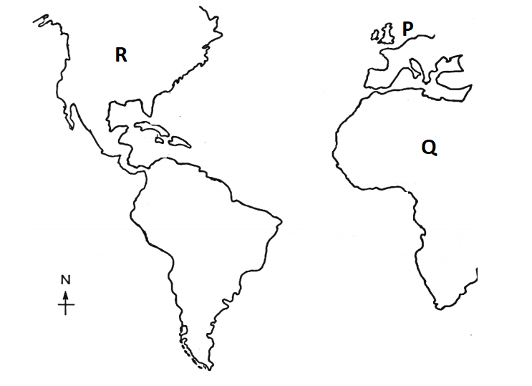**Figure 2 below shows continents P, Q and R involved in the triangle trade. Use it to answer questions that follows.**
2. a) On the map indicate the routes followed by traders using arrows. [3]

b) Mention two commodities that were used as means of exchange from continent **P** to continent **Q.**

__________________________________________________________________________

__________________________________________________________________________ [2]

1. State **two** effects of slave trade in continent **Q.**

__________________________________________________________________________

__________________________________________________________________________

__________________________________________________________________________

__________________________________________________________________________ [2]

1. a) Name the founder of Roman Civilisation.

__________________________________________________________________________ [1]

b) Mention any **two** contributions of the Roman civilization to the modern world.

__________________________________________________________________________

__________________________________________________________________________ [2]

c) Explain any **two** factors that led to the growth of the Roman civilization.

__________________________________________________________________________

__________________________________________________________________________

__________________________________________________________________________

__________________________________________________________________________ [4]

1. a) Define the term “**population change**”

__________________________________________________________________________

__________________________________________________________________________ [1]

b) Give **three** factors that influence population change in an area

__________________________________________________________________________

__________________________________________________________________________

__________________________________________________________________________ [3]

c) Give any **one** characteristic of each of the following people in Africa.

* + 1. The Hamites

__________________________________________________________________ [1]

* + 1. The Bantu

__________________________________________________________________ [1]

* + 1. Negroes

__________________________________________________________________ [1]

1. a) Give **two** ways of controlling soil erosion.

__________________________________________________________________________

__________________________________________________________________________ [2]

b) Describe **two** types of soil erosion.

__________________________________________________________________________

__________________________________________________________________________

__________________________________________________________________________

__________________________________________________________________________ [4]

c) Define **forestry.**

__________________________________________________________________________

__________________________________________________________________________ [1]

1. a) In what ways are the minerals important? Give two points

__________________________________________________________________________

__________________________________________________________________________ [2]

b) Give any **one** factor that promotes gender balance at school

__________________________________________________________________________ [1]

c) What is the impact of gender inequality in society? Give two points.

__________________________________________________________________________

__________________________________________________________________________

__________________________________________________________________________

__________________________________________________________________________ [4]

**BIBLE KNOWLEDGE** (35 marks)

1. a) i. Define **triumphant entry**.

__________________________________________________________________________

__________________________________________________________________________ [2]

ii. Mention **two** events that occurred during Jesus triumphant entry into Jerusalem.

__________________________________________________________________________

__________________________________________________________________________ [2]

b) State any **two** things that Herod did to Jesus when he did not answer his questions.

__________________________________________________________________________

__________________________________________________________________________ [2]

c). Give a reason why Moses became angry with the Israelite and broke the table of the ten

commandments.

__________________________________________________________________________

__________________________________________________________________________ [1]

1. Why did the angel tell Joshua to remove shoes from his feet?

_________________________________________________________________________

_________________________________________________________________________ [2]

1. a) Why did pharaoh release Joseph from prison.

__________________________________________________________________________

__________________________________________________________________________ [2]

b) Mention two animals which were used in the Passover.

__________________________________________________________________________

__________________________________________________________________________ [2]

c). Describe the relationship between the church and politics.

__________________________________________________________________________

__________________________________________________________________________ [2]

d). State any **two** examples of modern technologies used in a church.

__________________________________________________________________________

__________________________________________________________________________ [2]

1. a) What led Samson to be captured by the Philistines?

__________________________________________________________________________

__________________________________________________________________________ [2]

b). Explain type of peaceful conflict resolution method used between Abraham and Lot when

their servants were in conflict.

__________________________________________________________________________

__________________________________________________________________________ [2]

c). State any **three** effects of conflicts among Christians

__________________________________________________________________________

__________________________________________________________________________

__________________________________________________________________________ [3]

1. a) Define the term **sacred message**.

__________________________________________________________________________

__________________________________________________________________________ [2]

b) Give any **two** ways in which Christians fulfil their mission.

__________________________________________________________________________

__________________________________________________________________________ [2]

c). State any **three** roles of Prophets.

__________________________________________________________________________

__________________________________________________________________________

__________________________________________________________________________ [3]

1. a) Give any **two** things Amos preached against in the Kingdom of Israel.

__________________________________________________________________________

__________________________________________________________________________ [2]

b) Give any **two** roles of a king?

__________________________________________________________________________

__________________________________________________________________________ [2]

`End of question paper