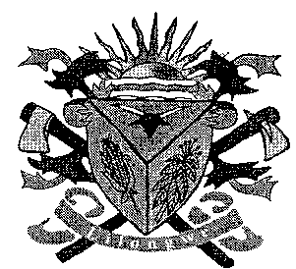**THE LILONGWE URBAN DISTRICT EXAMINATION BOARD**

**2023 END OF THIRD TERM EXAMINATIONS FOR STD 5**

**SOCIAL STUDIES /RELIGIOUS EDUCATION AND BIBLE KNOWLEDGE**

**(100 Marks)**

**Time allowed: ……………**

**Date: ……./…../…….**

**NAME OF CANDIDATE: ________________________________________________________________**

**(Surname first)**

**NAME OF SCHOOL: ___________________________________________________________________**

**INSTRUCTIONS**

* This paper contains **6 pages**. Please check

Answer **all** questions.

* This paper has **four** sections **A** **B C and D.**
* Follow instructions for each section carefully.

**IMPORTANT**

* Make sure you have written your **name** and **school name** on the question paper in the spaces provided.
* Please hand in your filled-in question paper to the invigilator at the end of the examination.

**SECTION A (30MARKS)**

1. How many districts are there in Malawi?
   1. 26 C. 32
   2. 28 D. 25
2. Name the capital city of Malawi
   1. Zomba C. Lilongwe
   2. Karonga D. Mzuzu
3. Which of the district is found in the central region?
   1. Mzimba C. Mwanza
   2. Balaka D. Dowa
4. Who is the current president of Malawi?
   1. Lazarus Chakwera
   2. Dr Bakili Muluzi
   3. Dr Joyce Banda
   4. Dr Saulos Chilima
5. The following are means of transport except
   1. Boat C. Train
   2. Phone D. Ox- cart
6. _____ is the total number of people in an area
   1. Bravery C. Population
   2. Institution D. Gender
7. Name any two types of soil
   1. Land and water
   2. Animals and wind
   3. Loam and sun
   4. Sand and clay
8. What are physical features
   1. Landforms and drainage
   2. Hills and rivers
   3. Landforms and lakes
   4. Drainage and mountains
9. Identify the cardinal point marked C among the following

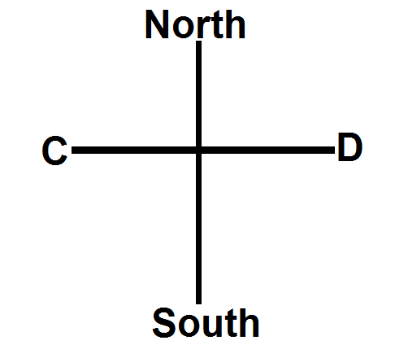

* 1. North C. South
  2. West D. East

**Figure I shows a means of transport. Use it to answer question 10 and 11**

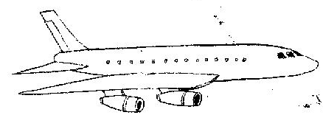

1. Identify the means of transport above
   1. Bicycle C. Aeroplane
   2. Train D. Ship
2. Which of the following is the advantage of the means of transport identified above in question 10
   1. Cheap C. Slow
   2. Expensive D. Fast
3. Mention one aquatic animal
   1. Lion C. Hare
   2. Hippo D. Snake
4. The ability to use, control and direct something or someone is called ______
   1. Man C. Power
   2. People D. Work
5. Which of the following is the most common form of abuse of power?
   1. Theft C. Fighting
   2. Witchcraft D. Corruption
6. Which of the following is the importance of soil
   1. Making clay pots
   2. Making roads
   3. Produce heat
   4. It has more stones

**Figure 2 is a table shows population figures by district . use it to answer questions 16 and 17**

|  |  |
| --- | --- |
| **District** | **Population** |
| Balaka | 2329,046 |
| Lilongwe | 1,337,777 |
| Chitipa | 125,619 |
| Zomba | 54 04 28 |

1. Which district has the highest population
   1. Bakala C. Chitipa
   2. Lilongwe D. Zomba
2. Which district has the lowest population
   1. Zomba C. Chitipa
   2. Lilongwe D. Balaka
3. Chikulamayembe means _______
   1. A farmer
   2. Hoes made of hands
   3. Head of state
   4. Carrier of hoes
4. In which district is Mulanje mountain ?
   1. Mulanje C. Dowa
   2. Mchinji D. Salima
5. Movement of people away from an area is called ____
   1. Birth C. Migration
   2. Emigration D. Immigration
6. Which of the following organizations helps to check the abuse of power
   1. Bravery and power
   2. UNICEF
   3. Ombudsman and anti – corruption bureau
   4. NAC
7. Who were the earliest settlers in Malawi
   1. Chikulamayembe
   2. Kalonga
   3. Balowoka
   4. Akafula
8. What name is given to a day set aside by the government to remember some Malawian who have suffered or died the sake of others?
   1. Martyr’s Day
   2. Kamuzu Dau
   3. Christmas Day
   4. Republic Day
9. Which of the following are road signals
   1. Hump
   2. Arm movement
   3. Pedestrian crossing
   4. Road
10. What term is given to equal treatment of males and females in a family, school, community or society
    1. Gender bias
    2. Gender inequality
    3. Gender equality
    4. Gender inequality
11. Which of the following departments provides security services
    1. Fisheries
    2. Veterinary
    3. Fisheries
    4. Police services
12. Which of the following is the right of children?
    1. Right to play
    2. Right to make noise
    3. Right to fight
    4. Right to kill
13. Why is bravery important?
    1. Promotes messages
    2. Promotes peace
    3. Promotes enemity
    4. Promotes hatred
14. Which of the following is a way of preventing HIV and AIDS
    1. Having unprotected sex
    2. Sharing sharp objects
    3. Abstinence
    4. Cultural practices
15. Which of the following is an example of a natural disaster?
    1. Food C. Births
    2. Death D. Floods

**SECTION B (35MARK)**

1. (a) Name two early kingdoms of Malawi
2. ______________________________________________________________________________
3. ________________________________________________________________________2marks

(b) State any two effects of population change

1. ______________________________________________________________________________
2. ________________________________________________________________________2marks

(c) Mention any two importance of lakes

1. ______________________________________________________________________________
2. ________________________________________________________________________2marks

(d) Give the meaning of the term ‘status’

____________________________________________________________________________1mark

1. (a) Mention three people in Malawi who showed acts of bravery and courage
2. ______________________________________________________________________________
3. ______________________________________________________________________________
4. ________________________________________________________________________3marks

(b) Draw the political structure of the Nkhamanga kingdom

3marks

(c) What is the other name of cardinal points

____________________________________________________________________________1mark

1. (a) List down three regions found in Malawi
2. ______________________________________________________________________________
3. ______________________________________________________________________________
4. ________________________________________________________________________3marks

(b) Name any two institutions that provide banking services

1. ______________________________________________________________________________
2. ________________________________________________________________________2marks

(c) In which region are the following districts

1. Rumphi _________________________________________________________________1mark
2. Balaka __________________________________________________________________1mark
3. (a) State any two causes of road accidents
4. ______________________________________________________________________________
5. ________________________________________________________________________2marks

(b) List down any two cheap means of communication

1. ______________________________________________________________________________
2. ________________________________________________________________________2marks

(c) Give any two road users

1. ______________________________________________________________________________
2. ________________________________________________________________________2marks

(d) On which side of the road should a pedestrian walk?

____________________________________________________________________________1mark

1. (a)Mention ant two organizations that can control abuse of power
2. ______________________________________________________________________________
3. ________________________________________________________________________2marks

(b) State any two family roles and responsibilities

1. ______________________________________________________________________________
2. ________________________________________________________________________2marks

(c) Mention two factors that led to the fall of the Maravi kingdom

1. ______________________________________________________________________________
2. ________________________________________________________________________2marks

(d) What is the advantage of a car as a means of transport?

____________________________________________________________________________1mark

**SECTION C (35MARKS)**

**BIBLE KNOWLEDGE**

1. (a) Mention two sons of Isaac
2. ______________________________________________________________________________
3. ________________________________________________________________________2marks

(b) Name any three disciples of Jesus Christ

1. ______________________________________________________________________________
2. ______________________________________________________________________________
3. ________________________________________________________________________3marks
4. (a) Mention two wives of Jacob
5. ______________________________________________________________________________
6. ________________________________________________________________________2marks

(b) Name two animals which were used in the Passover

1. ______________________________________________________________________________
2. ________________________________________________________________________2marks

(c) Give any two ways how HIV and AIDS is spread

1. ______________________________________________________________________________
2. ________________________________________________________________________2marks

(d) How many children did Jacob had?

____________________________________________________________________________1mark

1. (a) Mention three food item that made up Passover meal
2. ______________________________________________________________________________
3. ______________________________________________________________________________
4. ________________________________________________________________________3marks

(b) Name two responsibilities of children at church

1. ______________________________________________________________________________
2. ________________________________________________________________________2marks

(c) Give any two importance of love

1. ______________________________________________________________________________
2. ________________________________________________________________________2marks
3. (a) State two things God used to guide Hebrews on their journey
4. ______________________________________________________________________________
5. ________________________________________________________________________2marks

(b) Mention any two causes of drug and substance abuse

1. ______________________________________________________________________________
2. ________________________________________________________________________2marks

(c) Give any two situations Jesus showed love to everyone

1. ______________________________________________________________________________
2. ________________________________________________________________________2marks

(d) Define the term ‘tolerance”

____________________________________________________________________________1mark

1. (a) State the three major elements of the environment
2. ______________________________________________________________________________
3. ______________________________________________________________________________
4. ________________________________________________________________________3marks

(b) Why did Jacob’s family move from Canaan to Egypt?

____________________________________________________________________________________________________________________________________________________________2marks

(c) Where did Jesus begin his ministry?

____________________________________________________________________________1mark

(d) Who betrayed Jesus?

____________________________________________________________________________1mark

**SECTION D (35MARKS)**

**RELIGIOUS EDUCATION**

1. (a) Mention three ways in which God speaks to people
2. ______________________________________________________________________________
3. ______________________________________________________________________________
4. ________________________________________________________________________3marks

(b) State two basic needs in life

1. ______________________________________________________________________________
2. ________________________________________________________________________2marks

(c) Explain two importance of religious symbols and artefacts

1. ______________________________________________________________________________
2. ________________________________________________________________________2marks
3. (a) What does the following symbols stands for

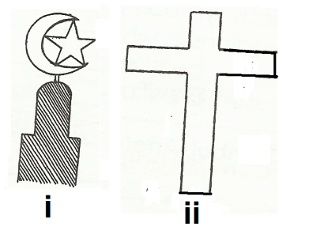

1. ______________________________________________________________________________
2. ________________________________________________________________________2marks

(b) Write the following abbreviation in full

1. RC ______________________________________________________________________1mark
2. PBUH____________________________________________________________________1mark

(c) Mention three common religions in Malawi

1. ______________________________________________________________________________
2. ______________________________________________________________________________
3. ________________________________________________________________________3marks
4. (a) Give any two ways of honouring God
5. ______________________________________________________________________________
6. ________________________________________________________________________2marks

(b) HIV stands for

H _______________________________________________________________________________

I ________________________________________________________________________________

V _________________________________________________________________________3marks

(c) Give any two other names of God

1. ______________________________________________________________________________
2. ________________________________________________________________________2marks
3. (a) What name are given to the holy book
4. Islam _________________________________________________________________________
5. Christianity______________________________________________________________2marks

(b) Give any three things created by God

1. ______________________________________________________________________________
2. ______________________________________________________________________________
3. ________________________________________________________________________3marks

(c) Name the founder of the following

1. Islam _________________________________________________________________________
2. Christianity________________________________________________________________2mark
3. (a) Explain two ways in which religious groups can assist people living in HIV and AIDS
4. ______________________________________________________________________________
5. ________________________________________________________________________2marks

(b) What does ATR stand for?

A _______________________________________________________________________________

T _______________________________________________________________________________

R _________________________________________________________________________3marks

(c) Give any two uses of water

1. ______________________________________________________________________________
2. ________________________________________________________________________2marks

**END OF QUESTION PAPER**