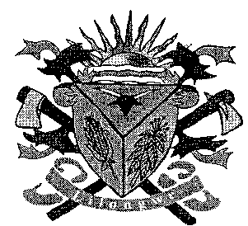**THE LILONGWE URBAN DISTRICT EXAMINATION BOARD**

**2023 END OF THIRD TERM EXAMINATIONS FOR STD 5**

**MATHEMATICS**

**(100 Marks)**

**Time allowed: 2hours**

**Date: 11/07/2023 10:00 – 12:00pm**

**NAME OF CANDIDATE: ________________________________________________________________**

**(Surname first)**

**NAME OF SCHOOL: ___________________________________________________________________**

**INSTRUCTIONS**

* This paper contains **6 pages**. Please check
* Answer **all** questions.
* Encircle the letter corresponding to the right answer to each question
* This paper has **two** sections **A** **and B.**
* Follow instructions for each section carefully.

**IMPORTANT**

* Make sure you have written your **name** and **school name** on the question paper in the spaces provided.
* Please hand in your filled-in question paper to the invigilator at the end of the examination

**SECTION A**

1. Fill in the missing number 1000 1100 ___ 1300
   1. 1120 C. 1002
   2. 1200 D. 1500
2. Write the number which has been modeled below

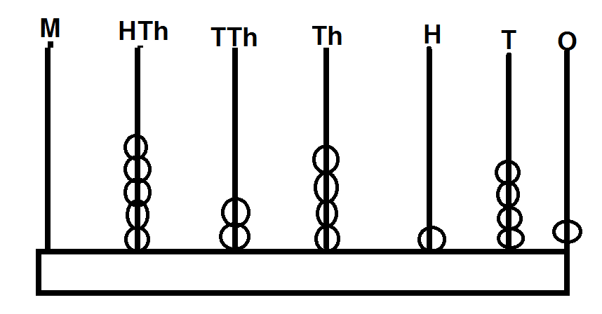

* 1. 52140 C. 52 4141
  2. 524 341 D. 526240

1. Add the following money

K t

70000 00

12480 00

+ 14200 75

* 1. K26680.75 C. K96680.75
  2. K7000.00 D. K82480.00

1. 1 2 1

× 9

* 1. 1079 C. 1082
  2. 1077 D. 1089

1. Complete the number sentences below

5p + 7p = _____

* 1. 15p C. 21p
  2. 12p D. 5p

1. Write six hundred and ten thousand two hundred and twenty four in figures
   1. 610, 224 C. 610 220
   2. 6102 024 D. 6001 024
   3. C.
   4. D.
2. 8 K24 840
   1. 3105 C. 3104
   2. 3005 D. 3125
3. Subtract

HTh TTh Th H T O

7 2 8 5 3 2

6 1 3 2 1 0

* 1. 105322 C. 115322
  2. 115222 D. 115422

1. Change 8 kilograms to grams
   1. 800g C. 81g
   2. 30g D. 8000g
2. Complete the equivalent fractions

|  |  |
| --- | --- |
|  |  |
|  |  |
|  |  |
|  |  |

* 1. C.
  2. D.

1. Change the following decimal into a fraction 0.12
   1. C.
   2. D.
2. Find the perimeter of the following rectangle

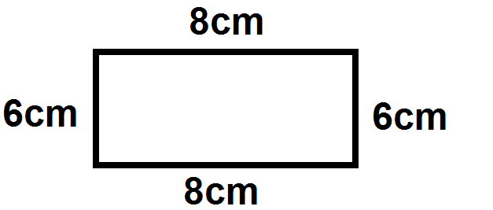

* 1. 28cm C. 222cm
  2. 14cm D. 24cm

1. Find the highest common factors (H.C.F ) of 12 and 18
   1. 3 C. 2
   2. 6 D. 8
2. Name the following shape
   1. Triangle C. Rectangle
   2. Circle D. Square
3. Complete the number pattern below

40, 37, 34, 31

* 1. 28, 22, 21 C. 28, 25, 22
  2. 28, 24, 22 D. 25, 23, 21

1. What is the area of the following shape?

|  |  |  |  |  |  |
| --- | --- | --- | --- | --- | --- |
|  |  |  |  |  |  |
|  |  |  |  |  |  |

* 1. 12 square C. 11square
  2. 10 square D. 9 squares

1. How many cm make 1m
   1. 1cm C. 10cm
   2. 1000cm D. 100cm
2. Which of the following shows line of symmetry

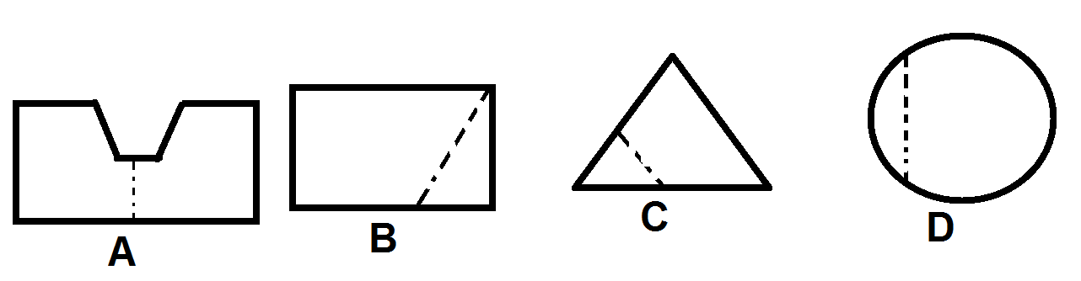

* 1. D C. D
  2. A D. C

1. What is the time on the analogue clock face below?

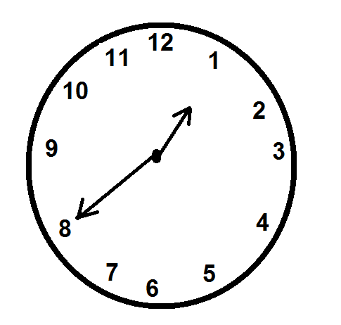

* 1. Quarter to 1
  2. 20 minutes past 8
  3. Quarter to 8
  4. 20 minutes to 1

**SECTION B (60MARKS)**

1. Complete the following patterns
   1. 84 78 72 66 ______ ______ ________ 42

3marks

* 1. Multiply : 236 by 5

4marks

1. Out of 80 5373 fish, 3 74 653 were bad. How many were good

4marks

1. Re – arrange the following numbers in descending order

460 000 , 475 160, 510 500, 495 140

3marks

1. (a) Find the area of the diagram below

|  |  |  |  |  |  |  |
| --- | --- | --- | --- | --- | --- | --- |
|  |  |  |  |  |  |  |
|  |  |  |  |  |  |  |
|  |  |  |  |  |  |  |
|  |  |  |  |  |  |  |

3marks

(b) Write as a decimal fraction

5marks

1. (a) Share equally K48 360 among 4 girls

3marks

(b) Model the number 125 650 on the abacus

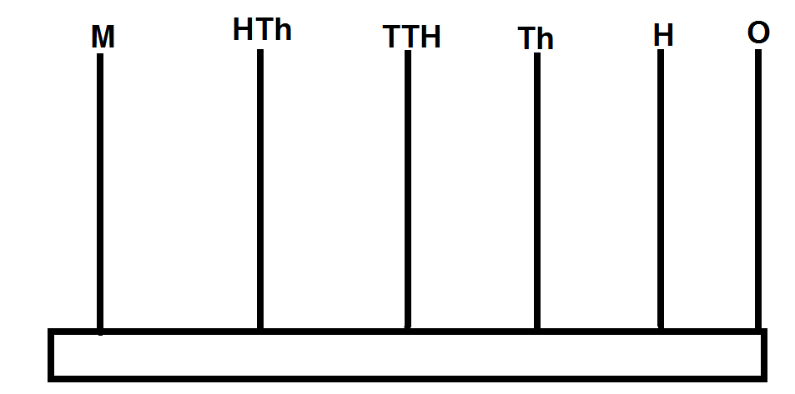

5marks

1. (a) A factory produced 900 00 bags of cement. If 821500 were good. How many bags were bad

4marks

(b) Express 2km 6dam in metres

2marks

1. Copy and complete the table below

|  |  |  |
| --- | --- | --- |
| **Colour** | **Number** | **Tally** |
| Green |  |  |
| Yellow | 3 |  |
| Pink |  |  |
| Blue | 13 |  |
| Black |  |  |
| Red | 9 |  |

5marks

1. (a) 34 02

× 25

4marks

1. (a) Find the area of the following shape

|  |  |  |  |  |
| --- | --- | --- | --- | --- |
|  |  |  |  |  |
|  |  |  |  |  |
|  |  |  |  |  |
|  |  |  |  |  |
|  |  |  |  |  |

3marks

(b) Write in short 8 pencils subtract 3 pencils

2marks

1. Work out the following bill

1 cupboard at K10, 50.00 each

5 chairs at K15, 90.00 each

1 sofa set at K1 380 .00 each

1 bag of flour at K5750 .00 each

5marks

1. Make a picture graph to show the number of trees planted by pupils one picture should represent one tree

|  |  |
| --- | --- |
| Learner | Number of trees |
| Chisomo | 6 |
| Chikondi | 3 |
| Chipiliro | 5 |
| Chifundo | 8 |
| Chimwemwe | 4 |
| Chitsanzo | 7 |

5marks

**END OF QUESTION PAPER**