**CHIGUMUKIRE ZONE EXAMINATIONS BOARD**

**2025 PRIMARY SCHOOL LEAVING CERTIFICATE MOCK EXAMINATIONS**

**ARTS AND LIFESKILLS**

(100 Marks)

**Time Allowed: 1 Hours**

**01:00 – 02:30 pm**

**Date: ……………… 2025**

**NAME OF CANDIDATE : ___________________________________________________________________**

(Surname First)

**SCHOOL NAME : ___________________________________________________________________**

|  |  |  |  |  |  |  |  |
| --- | --- | --- | --- | --- | --- | --- | --- |
| **Question Number** | **Tick If Answered** | **Do not write in these columns** | | | | | |
| **1 – 30** |  |  | |  | |
| **31** |  |  | |  | |
| **32** |  |  | |  | |
| **33** |  |  | |  | |
| **34** |  |  | |  | |
| **35** |  |  | |  | |
| **36** |  |  | |  | |
| **37** |  |  | |  | |
| **38** |  |  | |  | |
| **39** |  |  | |  | |
| **40** |  |  | |  | |
|  | | |  | |  | |

**Instructions**

1. **This paper consists of 8 printed pages. Please check**
2. Write your name and name of your school in the Spaces provided
3. This paper consists of two sections A and B
4. In section A encircle the letter A, B, C or D that represents the write answer for each question. In section B write your answers in the spaces provided
5. Write all your answers to the questions in both Sections
6. In the table provided on this page, tick against The question number you have answered.
7. Hand in your worked paper to the invigilator when time is called to stop writing

**IMPORTANT**

1. Make sure you have written your name, school
2. Name and examination number on the question

paper in the spaces provided in the spaces Provided.

**SECTION A**

**Multiple Choice** (30 marks)

* Encircle the letter A, B, C or D that best represent the right answer to the question

**EXPRESSIVE ARTS** (10 marks)

1. Which of the following dances is associated with the Chewa?
   1. Ingoma C. Uyeni
   2. Gule Wa Mkulu D. Manganje
2. The following are steps in garment construction **except**
   1. Measuring fabric C. Cutting fabric
   2. Producing fabric D, Sewing fabric
3. Which of the following is an importance of repetition and contrast in art work?
   1. To add beauty
   2. For long lasting
   3. To have many colours
   4. To prevent rust
4. The following are the ways of making sure that a bath shelter and a sun table last for a long time **except**
   1. Using local materials
   2. Using strong poles
   3. Using it properly
   4. Following procedures
5. Which of the following is a risk in weaving?
   1. Burning ones finger with fire
   2. Hitting ones fingers with pieces a hummer
   3. Pricking ones finger with pieces of bamboo
   4. Pricking ones fingers with sewing needles
6. Which of the following artistic activities require performers to wear costumes?
   1. Football C. Netball
   2. Jumping D. Drama
7. What does the dynamic symbol below mean?
   1. Singing very softly
   2. Singing very loudly
   3. Singing moderately soft
   4. Holding sound for sometime
8. In the component of general space which sporting activities does not need air pattern?
   1. Netball C. Chess
   2. Javelin D. Jumping
9. What name is used to describe physical exercise done by following music?
   1. Physical education
   2. Mirroring activities
   3. Dancing
   4. Aerobics

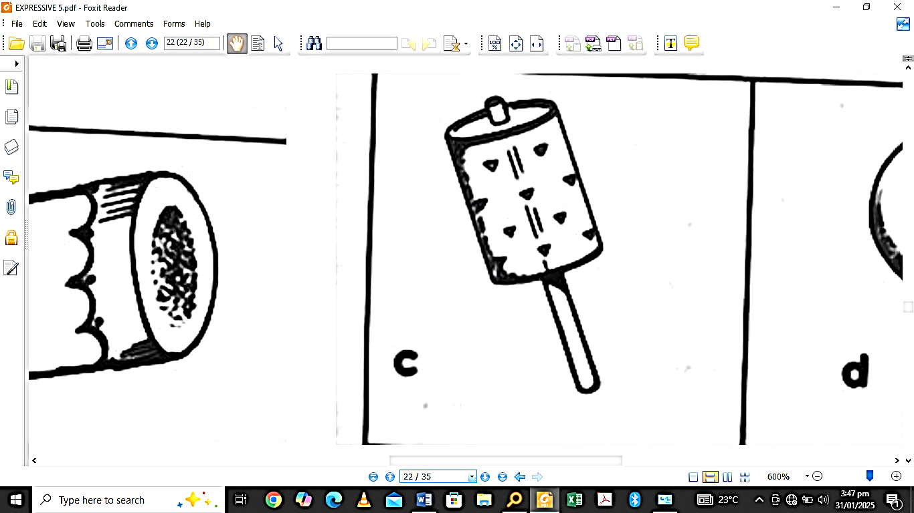**Figure 1 is a diagram showing an example of un tuned musical instrument. Use is to answer question 10.**

1. How is the instrument above played?
   1. Blowing C. Beating
   2. Shaking D. Plucking

**LIFE SKILLS** (20 marks)

1. Which of the following factors may prevent one from achieving his or her goals?
   1. Having self-confidence
   2. Proper planning
   3. Working hard
   4. Excessive responsibilities
2. Which of the following is a situation that requires planning?
   1. Entrepreneurship
   2. Peer pressure
   3. Loss of loved one
   4. Helping the less privileged
3. What name is given to the sense of right or wrong?
   1. Culture C. Values
   2. Morals D. Traditions
4. Which of the following factors destroys relationships?
   1. Discipline C. Honesty
   2. Cooperation D. Dishonesty

***Jane is in standard 5. One day while playing at school she fell down. Since that day her friends laughed at her every time. As a result, she is refusing to go to school.***

Use this information to answer questions 15 and 16.

1. How can Jane be helped to go to school again?
   1. Finding a part time teacher for her
   2. Giving her pocket money
   3. Buying books for her
   4. Counselling her
2. Which of the following morals values was lacking in Jane’s friends?
   1. Empathy C. Trust worthy
   2. Faithfulness D. Honesty
3. Name any side effects of ARV’s
   1. Loss of weight C. Diarrhoea
   2. Short sight D. Asthma
4. The protection that your body has against diseases is called ….
   1. Syndrome C. HIV
   2. Immune D. Deficiency
5. Which of the following is not a challenge that the youth may encounter?
   1. Orphan hood
   2. Sexual abuse
   3. Drug and substances abuse
   4. Self esteem
6. Which of the following is not a cause of sexual harassment and abuse?
   1. Orphan hood
   2. Cultural pressure
   3. Break up of families
   4. Being assertive
7. The following is a way of rebuilding self-esteem.
   1. Positive comments
   2. Negative comments
   3. Not understanding oneself
   4. Poor upbringing
8. Which of the following is the importance of preventing mother-child transmission as a fight against HIV and AIDS?
   1. To detect antibodies to HIV
   2. To know is infected
   3. For children to have human rights
   4. So that babies are born HIV free
9. Which of the following best completes the futures wheel?
   1. Peer pressure C. Premarital
   2. Poverty D. Violence
10. Give an example of the less privileged
    1. The aged C. Prostitutes
    2. Business people D. Pastors
11. Which of the following is a problem associated with adolescents?
    1. Self-awareness
    2. Good development
    3. High self esteem
    4. Early pregnancy
12. Which of the following is not a way of caring for people with chronic illness?
    1. Seeking medical attention
    2. Bathing them regularly
    3. Stigmatizing sick person
    4. Providing them with nutritious food

***A standard 8 boy at a certain primary school lost his parents as he was about to write examinations.***

Use this information to answer questions 27 and 28.

1. Which of the following would be the negative effect of the boy’s situation?
   1. High self confidence
   2. Stress and anxiety
   3. Passing his examinations
   4. Selection to secondary school
2. Which of the following could be the best way for the boy to manage his situation?
   1. Guidance and counselling
   2. Providing medical help
   3. Telling him to get employed
   4. Telling him to get married

**Study figure 2 below and use it to answer questions 29 and 30.**

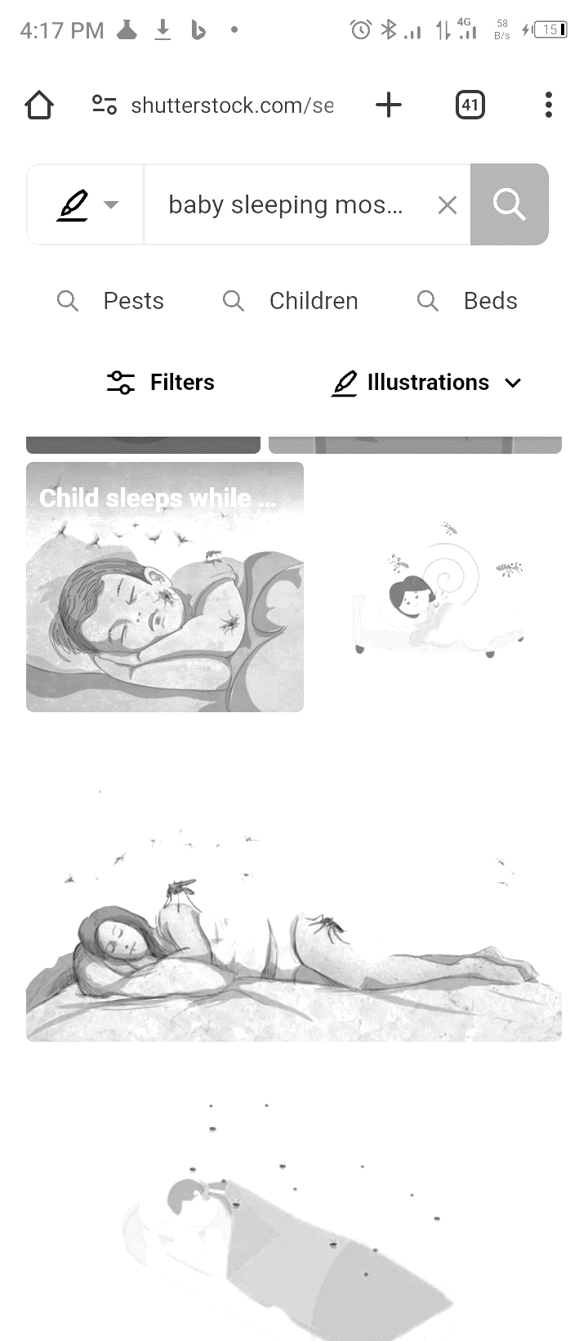

1. Name a disease that a person can suffer from the above situation
   1. TB C. Syphilis
   2. Malaria D. HIV and AIDS
2. Which of the following ways can be used to prevent the disease mentioned above?
   1. Washing beddings regularly
   2. Eating balanced diet
   3. Sleeping under treated mosquito net
   4. Abstain sexual intercourse

**SECTION B**

**Structured Questions** (70 marks)

* Answer all questions in the space provided

**EXPRESSIVE ARTS** (40 marks)

1. a. Mention **one** skill in each of the following.
2. Football

___________________________________________________________________ [1]

1. Volleyball

___________________________________________________________________ [1]

b) Mention any **one** way of preventing accidents in sports and games.

_______________________________________________________________________

_______________________________________________________________________ [1]

c. Give **one** importance of rules in sports and games.

_______________________________________________________________________ [1]

d. Name the game which team involves team of leaners forming a wide circle.

_______________________________________________________________________ [1]

e. i) Define **papier mache**.

____________________________________________________________________

____________________________________________________________________ [2]

ii) List one material which is used as a mould on making paiper mache.

____________________________________________________________________ [1]

1. a. i) Define the term **improvisation**.

____________________________________________________________________

____________________________________________________________________ [1]

ii) What is the different between comedy and tragedy?

____________________________________________________________________

____________________________________________________________________ [1]

b. i) Give **one** characteristics of good dye.

____________________________________________________________________ [1]

ii) State **one** key aim of **TALULAR**.

____________________________________________________________________ [1]

iii) Mention **one** factor to consider when producing resources.

____________________________________________________________________ [1]

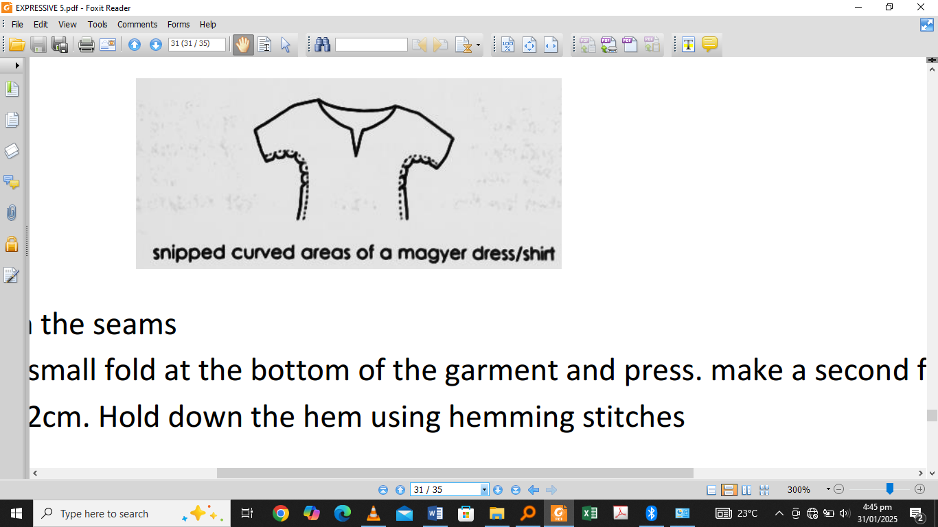**Figure 3 is an artistic item. Study it to answer questions that follow;**

1. a. i) Name the item shown in the diagram above.

____________________________________________________________________ [1]

ii) State any **two** sewing stitches.

____________________________________________________________________

____________________________________________________________________ [2]

iii) Mention any **one** traditional dance that promote gender equality

____________________________________________________________________ [1]

1. a. i) A point in a story where the interest is highest is called ________________________ [1]

ii) Which component of general space refers to locomotors action?

____________________________________________________________________ [1]

iii) Define hooliganism in sports.

____________________________________________________________________

____________________________________________________________________ [1]

iv) State the meaning of bringing a black chicken to a chief among the Chewa.

____________________________________________________________________

____________________________________________________________________ [1]

b. i). Name any **one** activity that can be used to communicate non-verbally.

____________________________________________________________________ [1]

ii). Mentioned any **two** garments which convey different cultural messages.

____________________________________________________________________

____________________________________________________________________ [2]

iii). Give any **one** artistic activity which uses tempo.

____________________________________________________________________ [1]

c. Figure 4 is a diagram of an artistic item. Use it to answer the questions that follow:

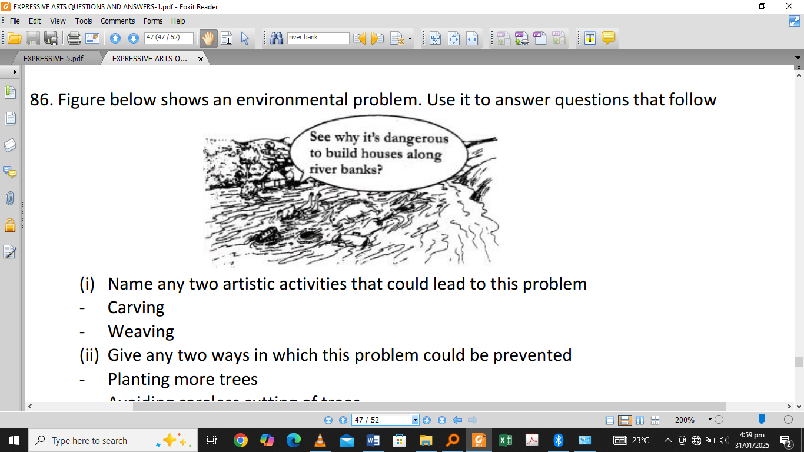

i) Name any **two** artistic activities that could lead to this problem.

____________________________________________________________________ [1]

____________________________________________________________________ [1]

ii) Describe any **one** way in which the problem can be prevented.

____________________________________________________________________ [1]

1. a. i) Explain any **one** importance of team work?

____________________________________________________________________ [1]

ii) Write down **two** examples of multicultural performances.

____________________________________________________________________

____________________________________________________________________ [2]

iii) State any **one** way in which a young person would show respect when receiving

things from elders.

____________________________________________________________________

____________________________________________________________________ [1]

b. (i) Mention any **two** career opportunities that exist in the communities.

____________________________________________________________________

____________________________________________________________________ [2]

ii) State any **one** way in which career opportunity can be explored.

____________________________________________________________________

____________________________________________________________________ [1]

iii) Name any **two** awareness activities that could be done before choosing a career.

____________________________________________________________________

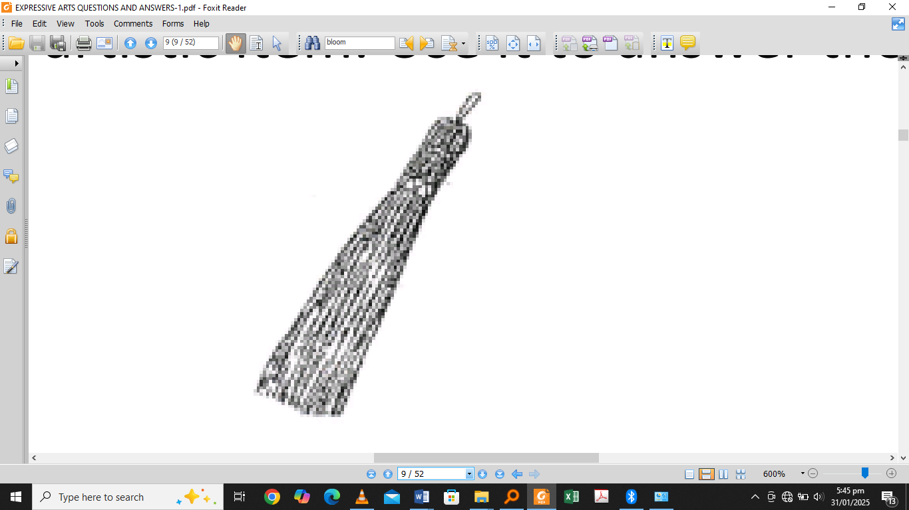____________________________________________________________________ [2]

**Figure 5 is a diagram of an artistic item. Use it to answer the questions that follow.**

c. i) Name the artistic item.

____________________________________________________________________ [1]

ii) Mention the skill used to produce the item.

____________________________________________________________________ [1]

iii) Give **one** material that can be used to make the item

____________________________________________________________________ [1]

**LIFE SKILLS** (30 marks)

1. a. What is the difference between discharge planning and referral process.

_______________________________________________________________________

_______________________________________________________________________ [2]

b. State **one** risky behavior that could lead to the spread of HIV.

_______________________________________________________________________ [1]

c. Mention **two** factors that influence sexuality.

_______________________________________________________________________

_______________________________________________________________________ [2]

d. i) State **one** way that can assist drug and substances abuses to stop their habits.

_______________________________________________________________________

_______________________________________________________________________ [1]

ii) List **one** example in each of the following;

* + - Drug = ______________________________________________ [1]
    - Substances = ______________________________________________ [1]

e. Give **two** problems associated with home-based care and support.

_______________________________________________________________________

_______________________________________________________________________ [2]

**Study the case study below and answer the questions that follows.**

*Melina a standard 7 girl heard two boys discussing that sex done in water can not make one get*

*pregnancy. She was taken up and forced on boy to experiment the situation.*

1. a. i) What is the danger of misconception in the story,

_______________________________________________________________________

_______________________________________________________________________ [1]

ii) Identify the skill Melina is lacking.

_______________________________________________________________________

_______________________________________________________________________ [1]

b. i) State any **two** changes that take place in boys when they grow up.

_______________________________________________________________________

_______________________________________________________________________ [2]

ii). Identify any **two** skills that can be used in effective communication concerning HIV and AIDS.

_______________________________________________________________________

_______________________________________________________________________ [2]

c. i) Write any **one** factors to consider when organizing peer guidance and counselling.

_______________________________________________________________________

_______________________________________________________________________ [1]

ii) State any **one** effect of stress and anxiety.

_______________________________________________________________________

_______________________________________________________________________ [1]

d. i) Mention **two** effects of not resolving conflict peacefully.

_______________________________________________________________________

_______________________________________________________________________

_______________________________________________________________________

_______________________________________________________________________ [2]

ii) Define **sexual harassment.**

_______________________________________________________________________

_______________________________________________________________________ [1]

1. a. i) State any **one** importance of entrepreneurship to the family.

_______________________________________________________________________

_______________________________________________________________________ [1]

ii) Name **two** types of toilets

_______________________________________________________________________

_______________________________________________________________________ [2]

1. b. i) Write any **one** role of HIV testing and counselling

_______________________________________________________________________

_______________________________________________________________________ [1]

iii) Complete the future wheel below by filling A and B.

A

Fighting

famine

B.

Effects of conflicts

[2]

1. a. State **two** right of people living with HIV and AIDS

_______________________________________________________________________

_______________________________________________________________________ [2]

1. List **any** form of child abuse

_______________________________________________________________________

_______________________________________________________________________ [1]

`End of question paper