**THE LILONGWE URBAN DISTRICT EXAMINATION BOARD**

**2023 END OF THIRD TERM EXAMINATIONS FOR STD 7**

**PRIMARY SCIENCE**

**(100 Marks)**

**Time allowed: ……………**

**Date: ……./…../…….**

**NAME OF CANDIDATE: ________________________________________________________________**

**(Surname first)**

**NAME OF SCHOOL: ___________________________________________________________________**

**INSTRUCTIONS**

1. This paper contains **6pages.** Please check.
2. This paper has two sections **A** and **B**. section **A** consists of **40 multiple choice** questions carrying **1 mark** each. Encircle a letter of your choice representing the right answer to each question. **Section B** has **10 structured** **questions**. Write your answers to this section on the question paper in the spaces provided. The maximum number of marks for each answer is indicated against the questions.
3. Answer **all** questions
4. In the table provided on this page, **tick** against the question number you have answered
5. **IMPORTANT**
   * Please make sure you have written your **name**, **school name**, on the question paper.
   * Please hand in your filled-in question paper to the invigilator at the end of the examination

|  |  |  |  |
| --- | --- | --- | --- |
| **Question number** | **Tick question 41 – 50 if answered** | **Do not write in these columns** | |
| 1- 40 |  |  |  |
| 41 |  |  |  |
| 42 |  |  |  |
| 43 |  |  |  |
| 44 |  |  |  |
| 45 |  |  |  |
| 46 |  |  |  |
| 47 |  |  |  |
| 48 |  |  |  |
| 49 |  |  |  |
| 50 |  |  |  |
|  | |  |  |

**SECTION A**

**AGRICULTURE**

1. Which of the following is the activity involved in land preparation for maize growing
   1. Harvesting
   2. Pruning
   3. Weeding
   4. Clearing the land
2. To which sub branch of agriculture does the keeping of bees belong?
   1. Poultry C. Fish farming
   2. Apiculture D. Goat farming
3. Which of the farming is the characteristics of a natural forest
   1. It comprises of different varieties of trees
   2. It comprises of one varieties of trees
   3. Trees grow in a specific pattern
   4. Trees ate taken care of

**Figure 1 is a diagram of a farm tool. Study it and answer questions 4 and 5**

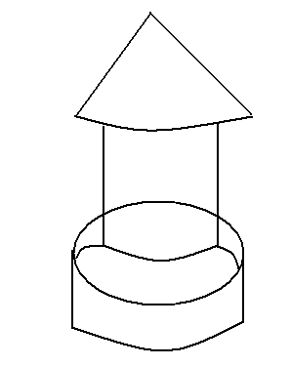

1. The farm tool is _________
   1. Water trough
   2. Water cane
   3. Feed trough
   4. Incubator
2. Which farm enterprise is the farm tool used ?
   1. Bee enterprise
   2. Goat enterprise
   3. Cattle enterprise
   4. Poultry enterprise
3. Why is hardening off of seedlings important?
   1. Helps the seed to germinate easily
   2. Prevent disease in seedlings
   3. Helps seedlings grow healthy
   4. Prepare the seedlings for hard conditions
4. A leaner weighed a sample of soil before putting it in the sun to dry. She then weighed it again and recorded the results. The aim of the experiment was to find out if soil contains
   1. Water
   2. Humus
   3. Micro – organisms
   4. Air
5. Which of the following is an example of financial farm record?
   1. Labour record C. Crop record
   2. Sales record D. Layers record

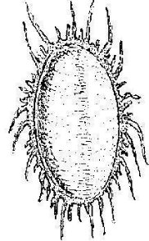

1. Identify the pest of the flowers above
   1. Aphids C. Flea
   2. Tick D. Mealy bug
2. What damage does it cause on flowers
   1. Damage roots
   2. Damage stem
   3. Causes the wilting of a plant
   4. It sucks plant juice
3. What causes coccidiosis in chickens?
   1. Protozoa C. Bacteria
   2. Virus D. Fungus
4. Why top soil good for crop production?
   1. It has more plant nutrients
   2. It has large air spaces
   3. It has very small particles
   4. It holds little amount of water
5. Which system of agroforestry involves planting trees and shrubs around the boundaries
   1. Live Fence
   2. Folder banks
   3. Improved fallows
   4. Alley cropping
6. Which of the following is the characteristics of Flemish giant?
   1. Black in colour
   2. Grey in colour
   3. White in colour
   4. Brown in colour
7. In which of class of vegetables does onion belong?
   1. Leaf vegetables
   2. Legume vegetables
   3. Root vegetables
   4. Fruit vegetables
8. What finished product can be obtained from a cow hide?
   1. Dresses C. Books
   2. Pens D. Shoes
9. Which of the following are the types of trees grown in Malawi
   1. Gmelina and Exotic
   2. Indigenous and Msangu
   3. Exotic and indigenous
   4. Gmelina and commercial
10. A large area of land covered by trees and grasses is called________
    1. Agriculture C. Forest
    2. Mountain D. Woodlot
11. The following are major elements of agriculture environment except
    1. Water C. Sunlight
    2. Maize D. Soil
12. Why planting cuttings should be planted at an angle or in a slanting manner?
    1. To prevent damping off and leaching
    2. To avoid destroying the planting material
    3. To allow water to settle down the planting material
    4. To maximize the use of land

**SCIENCE AND TECHNOLOGY**

1. Which type of force is produced as a result of rubbing two bodies?
   1. Magnetic force
   2. Elastic force
   3. Frictional force
   4. Gravitational force
2. Which of the following is an example of ball and socket joint?
   1. Shoulder joint
   2. Finger joint
   3. Knee joint
   4. Elbow joint

**Figure 3 is a diagram showing properties of light. Use it to answer questions 23 – 24**

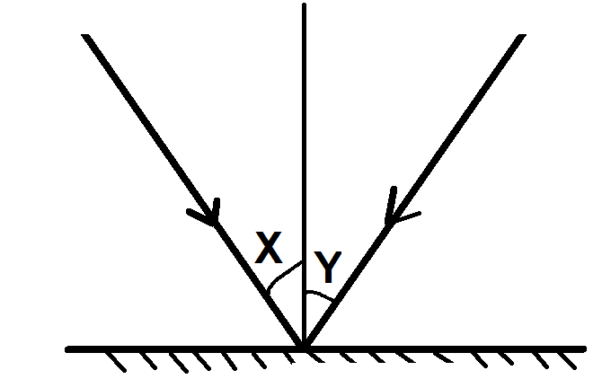

1. Which property of light is shown above?
   1. Light has speed
   2. Light can be refracted
   3. Light travels in straight lines
   4. Light can be reflected
2. Name the angle marked Y
   1. Normal angle
   2. Angle of refraction
   3. Angle of incidence
   4. Angle of reflection
3. Invertebrate animals with jointed legs are known as ____
   1. Molluscs C. Nematodes
   2. Anthropods D. Annelids
4. Which of the following happens when liquids changes to gas
   1. Evaporation C. Condensation
   2. Melting D. Freezing
5. Which room in the house is used for taking meals?
   1. Bed room C. Kitchen
   2. Dining room D. Sitting room
6. Which of the following is a common physical change in both boys and girls during adolescence
   1. Produce sperm
   2. Develop deep voice
   3. Grow taller and heavier
   4. Skin becomes oily
7. Which of the following is a characteristics of wind dispersal seeds and fruits?
   1. Brightly coloured
   2. Have hook like features
   3. Have pods
   4. Have hairs

**Figure 4 below is a diagram of a human digestive system. Use it to answer question 30- 31**

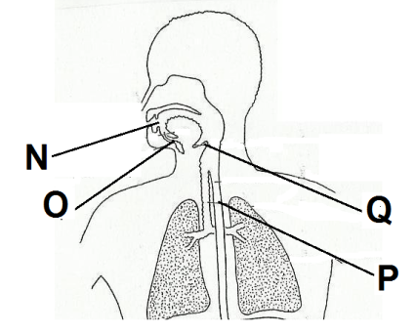

1. What is the function of the part marked Q
   1. Directing food into the intestine
   2. Storing food before swallowing
   3. Directing food into the oesophugus
   4. Producing digestive juices
2. What would happen if food particles entered the part marked P?
   1. The person would vomit
   2. The food would be swallowed
   3. The food would be digested
   4. The person would be chocked
3. Which of the following is an example of animals stains
   1. An egg C. Tea
   2. Rust D. Milk
4. What name is given to a reasonable guess to explain a particular event or observation?
   1. Data analysis C. Variable
   2. Hypothesis D. Investigation
5. Which of the following is the function of cerebellum in human beings?
   1. Control senses
   2. Breathing
   3. Coordination
   4. Digestion
6. Which of the following is not a condition necessary for the seed germination?
   1. Moisture C. Warmth
   2. Air D. Scar
7. Give one way how animals and plants depend on each other?
   1. For movement
   2. For plants
   3. For food
   4. For animals
8. Which of the following is a common food taboo and belief
   1. Girls should go to school
   2. Pregnant woman should eat eggs
   3. Children should not eat eggs
   4. Pregnant woman should not eat eggs
9. Which of the following is the first stage in scientific investigation?
   1. Knowing the problem
   2. Hypothesis
   3. Making conclusion
   4. Making prediction
10. The interpretation of the message by the receiver is called____
    1. Coding C. Decoding
    2. Computer D. Drum
11. How can someone get infected with tapeworms?
    1. Eating unwashed food
    2. Eating meat that is not well cooked
    3. Through walking bare footed
    4. Eating food without washing hands

**SECTION B (60MARKS)**

**AGRICULTURE**

1. (a) Define soil erosion?

____________________________________________________________________________1mark

(b) Explain any two effects of soil erosion on agricultural production

1. ______________________________________________________________________________
2. ________________________________________________________________________2marks

(c) Give any two importance of irrigation?

1. ______________________________________________________________________________
2. ________________________________________________________________________2marks

(d) Describe any two factors to consider when selecting good seeds for planting?

1. ______________________________________________________________________________
2. ________________________________________________________________________2marks

(e) Give any two activities done during land preparation

1. ______________________________________________________________________________
2. ________________________________________________________________________2marks
3. (a) Give two reasons why farmers keep farm records?
4. ______________________________________________________________________________
5. ________________________________________________________________________2marks

(b) Mention any two factors of agricultural production?

1. ______________________________________________________________________________
2. ________________________________________________________________________2marks

(c) Define irrigation

____________________________________________________________________________1mark

(d) State any two types of irrigation?

1. ______________________________________________________________________________
2. ________________________________________________________________________2marks
3. (a) Mention any two risks in farm business?
4. ______________________________________________________________________________
5. ________________________________________________________________________2marks

(b) Give any two ways of conserving water?

1. ______________________________________________________________________________
2. ________________________________________________________________________2marks

(c) Mention any two activities that are involved in packaging as an example of marketing function?

1. ______________________________________________________________________________
2. ________________________________________________________________________2marks

(d)Name any two farm implements that can be greased?

1. ______________________________________________________________________________
2. ________________________________________________________________________2marks

**Figure 5 is a diagram of soil profile. Study it carefully and answer questions 44a – b**

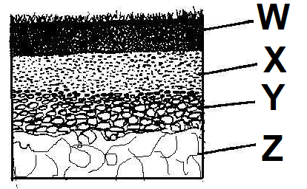

1. (a) Identify the parts labeled W and Y?

W_______________________________________________________________________________

Y__________________________________________________________________________2marks

(b) Name one micro- organism found in top soil?

____________________________________________________________________________1mark

(c) What is the other name for parent rock?

____________________________________________________________________________1mark

(d) Give any two examples of flowers that can be used as medicine?

1. ______________________________________________________________________________
2. ________________________________________________________________________2marks

**SCIENCE AND TECHNOLOGY**

1. (a)State any two problems of the digestive system?
2. ______________________________________________________________________________
3. ________________________________________________________________________2marks

(b) Give any two ways of marketing the toys

1. ______________________________________________________________________________
2. ________________________________________________________________________2marks

(c) Mention any one property of heat?

____________________________________________________________________________1mark

1. (a) State any two symptoms and signs of scurvy?
2. ______________________________________________________________________________
3. ________________________________________________________________________2marks

(b)List down any two leaf arrangement?

1. ______________________________________________________________________________
2. ________________________________________________________________________2marks

(c) Mention any two functions of the roots to the plant?

1. ______________________________________________________________________________
2. ________________________________________________________________________2marks

**Figure 6 below is a diagram. Use it to answer the questions that follow**

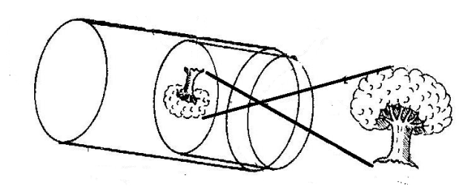

1. (a) Name the instrument above?

____________________________________________________________________________1mark

(b) State the property of light that is being illustrated using the instrument?

____________________________________________________________________________1mark

(c) Mention any two agents of pollination?

1. ______________________________________________________________________________
2. ________________________________________________________________________2marks
3. (a) Define matter?

____________________________________________________________________________1mark

(b) Mention any two effects of drugs and substance abuse to the brain?

1. ______________________________________________________________________________
2. ________________________________________________________________________2marks

(c) Give any two functions of human skeleton?

1. ______________________________________________________________________________
2. ________________________________________________________________________2marks

(d) State any two ways of classifying animals

1. ______________________________________________________________________________
2. ________________________________________________________________________2marks
3. (a) Explain the function of the hair found in the nose?

____________________________________________________________________________1mark

(b) Describe any two ways how animals protect themselves from enemies?

1. ______________________________________________________________________________
2. ________________________________________________________________________2marks

(c)Explain any two effects of food taboos to a pregnant woman?

1. ______________________________________________________________________________
2. ________________________________________________________________________2marks
3. (a) Define joint?

___________________________________________________________________________1mark

(b) What causes the following accidents

1. Burns and scalds ________________________________________________________1mark
2. Suffocation_____________________________________________________________1mark

**END OF QUESTION PAPER**