**CHIGUMUKIRE ZONE EXAMINATIONS BOARD**

**2025 PRIMARY SCHOOL LEAVING CERTIFICATE MOCK EXAMINATIONS**

**MATHEMATICS**

(100 Marks)

**Time Allowed: 2 Hours**

**08:00 – 10:00 am**

**Date: ……………… 2025**

**NAME OF CANDIDATE : ___________________________________________________________________**

(Surname First)

**SCHOOL NAME : ___________________________________________________________________**

**Instructions**

|  |  |  |  |  |  |  |  |
| --- | --- | --- | --- | --- | --- | --- | --- |
| **Question Number** | **Tick If Answered** | **Do not write in these columns** | | | | | |
| **1 – 20** |  |  | |  | |
| **21** |  |  | |  | |
| **22** |  |  | |  | |
| **23** |  |  | |  | |
| **24** |  |  | |  | |
| **25** |  |  | |  | |
| **26** |  |  | |  | |
| **27** |  |  | |  | |
| **28** |  |  | |  | |
|  | | |  | |  | |

1. **This paper consists of 8 printed pages. Please check**
2. Answer all questions. In Section A, encircle the letter corresponding to the right answer to each question. In Section B, write your answers in the spaces provided under each question.
3. There are **20** multiple questions in Section A and **8** Questions in Section B
4. You are provided with blank pages at the end of the paper for rough work for section A. Do not tear them off,
5. In Section B, you need to show all your working.
6. The use of electronic calculators is not allowed.
7. In the table provided on this page, tick against the question number you have answered.
8. Please make sure you have written your examination number, your name and school name on the question paper in the spaces provided.
9. Hand in your examination papers to the invigilator when time is called to stop writing

**SECTION A**

**Multiple Choice** (40 marks)

* Encircle the letter A, B, C or D that best represent the right answer to the question

1. What is DCXLIX in Hindu Arabic numerals?
   1. 549 C. 649
   2. 659 D. 759
2. Which of the following is a quarter turn?

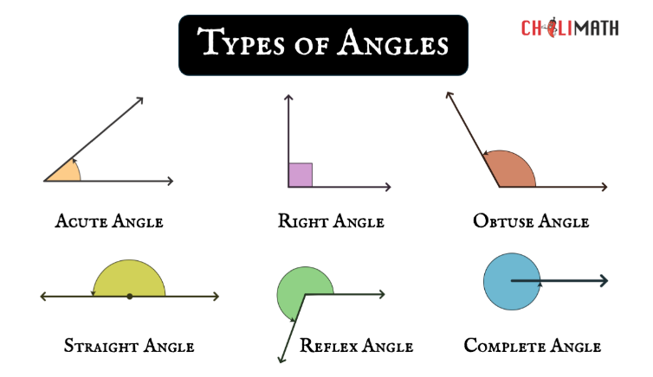

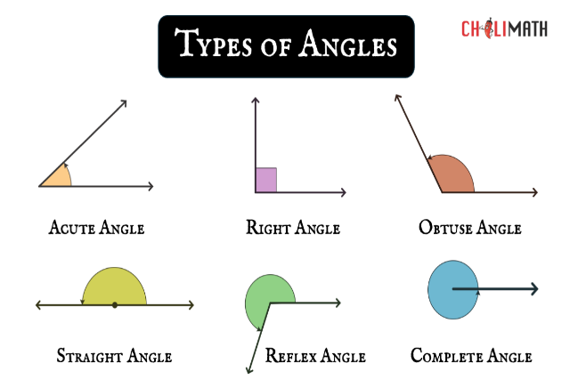

* 1. . C.

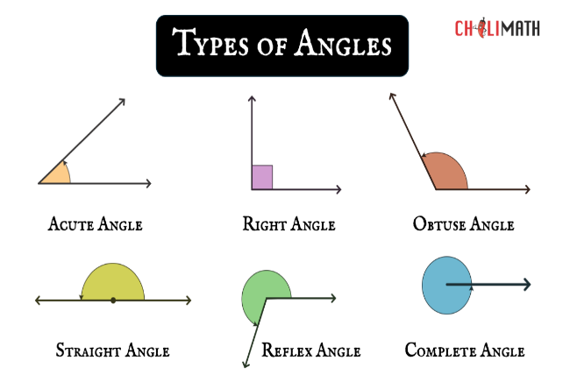

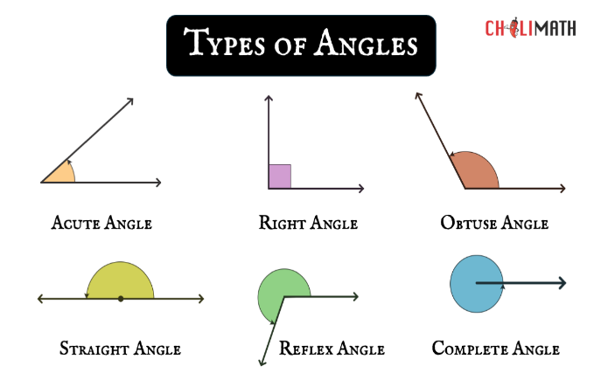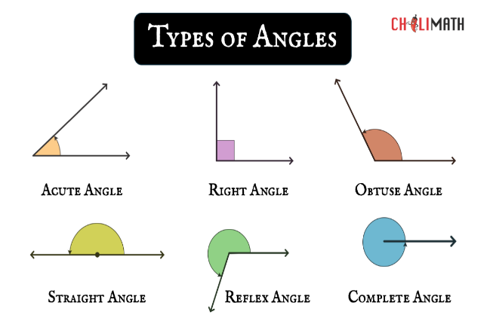

* 1. . D.

1. How many fortnights are there in 112 days?
   1. 8 C. 16
   2. 14 D. 34
2. Which of the following is the biggest fraction?
   1. C.
   2. D.
3. Which of the following is correct for the mathematical statement?

*the sum of y and 7 is less than or equal to 13*

* 1. Y + 7 = 13 C. y + 7 > 13
  2. Y + 7 > 13 D. y + 7 < 13

1. Find the total amount to be paid back on a loan of K60,000.00 for 10 years at 2% simple interest.
   1. K12,000 C. K48,000
   2. K30, D. K72,000
2. Find the median of the following numbers.

**3, 10, 8, 12, 6, 18**

* 1. 9.0 C. 18
  2. 9.5 D. 57

The table below shows the number of dogs vaccinated in a certain are for four months.

Use it to answer the questions 8 and 9.

|  |  |
| --- | --- |
| **Month** | **No. of dogs vaccinated** |
| January | *~~IIII~~ ~~IIII~~ ~~IIII~~ ~~II~~* |
| February | *~~IIII~~ ~~II~~* |
| March | *III* |
| April | *~~IIII~~ ~~IIII~~ I* |

1. Which month had the least number of dogs vaccinated?
   1. January C. March
   2. February D. April
2. What is the total number of Dogs in January and April?
   1. 17 C. 38
   2. 24 D. 28
3. What is the 4th Number in the following number pattern.

***36, 39, 42, ____***

* 1. 40 C. 41
  2. 44 D. 45

1. A Boy and a girl shared 120 tablets of soap in the ratio 3:2 respectively. What is the boy’s share?
   1. 72 C. 24
   2. 48 D. 40
2. What is the period of 5 years called?
   1. Centaury C. Decade
   2. Generation D. Instrum
3. What is the costing for sending the message in the table below at K280 per word?

*To: John Phiri Box 38 Kasungu*

*Send money for school uniform*

*From: Grace Phiri*

1. K200 C. K280
2. K240 D. K320
3. Write Five hundred and fifty million, five hundred and fifty thousand and five in figures.
   1. 505 505 550 C. 550 505 050
   2. 550 505 050 D. 550 505 500
4. An institution has 12 female workers and 6 male workers. What is the percentage of male workers in the institution?
   1. 30% C. 18%
   2. 33.33% D. 100%
5. A trader bought beans worthy K7,200.00 and sold them for K7,920,00. What profit in percent did the trader make?
   1. 10% C. 90%
   2. 11% D. 110%
6. Find the HCF of 13, 39, 52 and 65.
   1. 105 C. 39
   2. 13 D. 3
7. The cost of a shirt was K3,000. How much did the buyer pay if allowed a discount of 15%?
   1. K3,500 C. K2,250
   2. K3,015 D. K3,085
8. Express 28.45269 to 4 decimal places.
   1. 28.4 C. 28.5
   2. 28.4527 D. 28.45270
9. Yankho takes 2 hours and 30 minutes to walk a distance of 15km. Calculate Yanko’s speed per minute in minutes.
   1. 60m/min C. 100m/min
   2. 10m/min D. 125m/min

**SECTION B : STRUCTURED QUESTIONS**

(60 marks)

* Write your answers in the spaces provided.
* Show all your working.

1. a. Calculate the HCF of 1040 and 720

by continued division.

[5]

b. Simplify 16 + 8 ÷ 3)

[6]

1. a. A drum contains 114 litres of water. Later

72.5 litres was poured into it. How much water remained in the drum if 91.8 litres was used for washing clothes?

[3]

b. Simplify 0.12 – 0.02 x 0.65

[4]

1. a. Three farmers put together money in the

ratio 2:3:5 to buy fertilizer. Calculate the bags of fertilizers each farmer received if they bought 486 bags.

[7]

b. Table below shows Exchange rate

Use it to answer the question that follow.

|  |  |  |
| --- | --- | --- |
| **Currency** | **Buying** | **Selling** |
| US Dollar ($) | K139.10 | K141.89 |

Takondwa gave of $680 to Tawina.

What is the Kwacha value of the

remaining Dollars?

[4]

1. a. Work out the following bills

*10 loaves of bread at K55.00 each*

*15 packets of sugar at K75.00 each*

*8 bottles of cooking oil at K175.00 each*

*25 packets of salt at K95.00 each*

[4]

1. The table below shows income tax rates.

Use it to answer the question that follows.

|  |  |
| --- | --- |
| **Income per month** | **Rate for tax** |
| First K100,000 | 0% (tax free) |
| Next K50,000 | 15% |
| Excess (Over) K150,000 | 30% |

a. A worker earns K195,000 per month.

Find the tax the workers pay per month.

[6]

b. Calculate the amount of money to be paid

on a loan of K80,000.00 at the rate of 10% per annum for 2 years.

Calculate compound interest

[6]

1. Solve ***140 + 6y + 92 – y***

[4]

1. Figure below shows a drawing of a garden in form of a trapezium **W X Y Z** in which WX = 50m, **WZ**= 40m, **YZ**=70m, angle **WZY** = 60O and angle **XWZ** = 120O

W *50m* X

120O

*40m*

60O

Z *70m* Y

1. Using a scale of 1cm represent 10m,

draw the figure accurately.

[4]

1. On your drawing, measure and state the length of **XZ**.

[2]

1. Mr. Manjeza had K100,000.00 balance in hand on 01st April, 2023. During the month he made the following transactions.

2 April ……... Sold eggs for K8,000.00 Cash

10 April ……..Withdraw K5,000 from the Bank

21 April …….. Banked K4,500

Prepare a cash book for Mr. Manjeza and balance it

[8]

**End of question paper**