 **MKUKULA ZONE EXAMINATION BOARD**

**2024 - 2025 PRIMARY SCHOOL LEAVING CERTIFICATE MOCK EXAMINATION**

**STANDARD 8**

**MATHEMATICS**

**(100 MARKS)**

**Subject number: P131**

**Time allowed: 2 hr**

**Date: ____/_____/ 2025**

**NAME OF CANDIDATE: ____________________________________________________________________**

***(Surname first)***

**NAME OF SCHOOL: _______________________________________________________________________**

**Instructions**

|  |  |  |  |
| --- | --- | --- | --- |
| Question Number | Tick question if answered | Do not write in these columns | |
| 1 -20 |  |  |  |
| 21 |  |  |  |
| 22 |  |  |  |
| 23 |  |  |  |
| 24 |  |  |  |
| 25 |  |  |  |
| 26 |  |  |  |
| 27 |  |  |  |
|  | |  |  |

1. This paper contains 6 **pages** please check.
2. Write your **examination number** on each

page of this page.

1. This paper has two sections **A** and **B.**
2. In section **B** you are required to show all your working.
3. The use of electronic calculators is **not** allowed
4. Follow instructions for each section Carefully.

**Important**

1. Please make sure you have written your **name**

and **examination number** in the spaces

provided.

1. Hand in your question paper to the

invigilators when the time is called to stop

writing.

**SECTION A**. (40 marks)

**Multiple choice**

*Encircle later* ***A,B, C*** *or* ***D*** *that represent correct answer of your choice.*

1. From what number must 6489 be subtracted to give 654
2. 533
3. 7033
4. 6835
5. 7143
6. Which of the following is the arrangement of fraction starting with the biggest
7. 2/3, ¾, 3/5
8. 3/5, ¾, 2/3
9. ¾, 2/3, 3/5
10. 3/5, 2/3, ¾
11. What is **MCXXV**
12. 11115
13. 1115
14. 1125
15. 175
16. Jane scored 19 out of 25 and Dorothy scored 14 out of 25 marks in an English test. Calculate the difference between their scores in percentage.
17. 5%
18. 56%
19. 20%
20. 76%
21. By selling a chicken for K1700 a farmer made a loss of 15t in every kwacha. Find the price
22. K225
23. K1,955
24. K1,455
25. K2,000
26. Figure 1 shows a trapezium **ABCD**

**A** **B**

**D**  **C**

Which two sides are parallel to each other?

1. **AB** and **DC**
2. **AB** and **AD**
3. **BC** and **DC**
4. **BC** and **AD**
5. Bina and Chiko shared pens in the ratio 2:3 respectively. If Chiko got 18 pens, what is the total number of pens?
6. 12
7. 27
8. 30
9. 45
10. The total mass of a tin with water in it is 35.72g. if the mass of water only is 28.36g, what is the mass of the tin?
11. 7.36g
12. 7.46g
13. 17.36g
14. 62.08g
15. What is the period of 5 years called
16. Century
17. Decade
18. Generation
19. Instrum
20. A pair of trousers marked at K6,500 was sold at K5,850. What was the discount percentage
21. 9%
22. 10%
23. 11%
24. 12%
25. Table 1 shows marks and number of leaners reprented in a tally form

|  |  |
| --- | --- |
| **Marks (%)** | **Tally** |
| 10 | III |
| 20 | ~~IIII~~  I |
| 30 | III |
| 40 | ~~IIII~~ I |

What is the mean mark?

1. 10
2. 25
3. 30
4. 40
5. Whats is the median mark?
6. 35
7. 40
8. 20
9. 25
10. The perimeter of a rectangular garden is 62m. If the length of rectangle is 17m. What is its width?
11. 14
12. 28
13. 31
14. 45
15. Calculate the perimeter of the figure below

8 cm

21 cm

1. 58 cm
2. 29 cm
3. 70 cm
4. 168 cm
5. What is the rule followed when generating the following patten: 2, 4, 16, 96
6. Multiply by 2
7. Add previous number
8. Subtract by 8
9. Squaring it self
10. If a leaner covers a distance of 6 km to school in 1½ hrs. Find her speed.
11. 4 hours
12. 4 km
13. 4 km/hr
14. 2 km/hr
15. Calculate the simple interest on K3,200.00 for 2 years at 5% per annum
16. K340.00
17. K640.00
18. K320.00
19. 230.00
20. Mike wanted to stimulate this expression into a marthematical sentence. The sum of X and 5 is less than or equal to 4. What would be the correct way?
21. X + 5 ≤ 4
22. X + 5 ≥ 4
23. X + 4 > 4
24. X + 4 ≤ 5
25. Express 15.0951 to 3 significant figure
26. 15.0
27. 15.01
28. 15.09
29. 15.1

Figure below is a drawing of a triangle. Use it to answer question 20.

3 cm

2 cm

3 cm

1. Name the type of triangle.
2. Equilateral
3. Isosceles
4. Scalene
5. Right angled

**SECTION B**. (60 marks)

1. a. Multiply the difference between 701.2 and 681 by 2.3. Give your answer to 1 decimal place.

(3 marks)

b. simplify 2 2/9  x (3 ¾ - 1 5/8) ÷ 1 1/3

(4 marks)

1. a. The figure below shows a triangular space ABC with a flower lawn 1m wide. BC= 8cm and DH = 20 m.

A

1m

D

20m

┐

B 1m E H F 1m C

8m

Calculate the area of the lawn.

(6 marks)

b. a shirt marked K2,500 was sold for K2,250. Calculate the discount percent.

(3 marks)

1. a. The average mass of 13 bags of maize is 52.2kg. if 3 bags are sold, the average mass of remaining bags is 52.7Kg. Calculate the total mass of the three bags.

(4 marks)

b. a lady spends 2/5 of her salary on food, 1/6  on house rent and remaining K26,000 on clothes. Calculate her monthly salary.

(5 marks)

1. (a). Calculate the difference between the simple interest and compound interest on K100,00 for 2 years at 20% per annum

(6 marks)

b. The product of two numbers is 288. One of the numbers is the difference between 11 and 2. Find the other number.

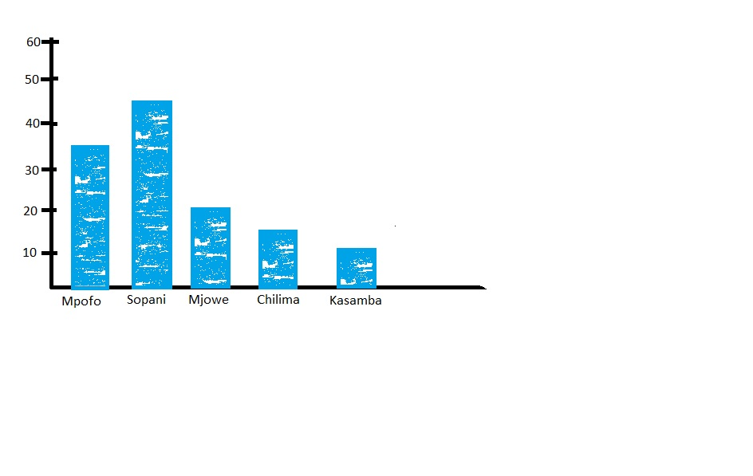(4 marks)

1. Study the bar graph showing rainfall record at different villages.
   1. Find the total amount of rainfall at Chilima village.

(1 mark)

* 1. What was the highest amount of rainfall recorded in 5 villages.

(1 mark)

* 1. Calculate the difference between amount of rainfall at Kasamba and Mjowe village.

(2 marks)

1. (a). A farmer bought the following: 11Kgs of beef at K465 per Kg, 3 baskets of tomatoes at K250 per basket, 30 Kgs of sugar at K1,350 per 10Kgs, 9 bunches of nion at 175 per 3 bunches. Calculate the total money spent?

(6 marks)

(b) A company shared K201,551.00 among its longest serving employees, Mr. Chirwa, Mrs. Moyo and Miss Dziko in the ratio of 2:3:2. Find how much each one of them received

(6 marks)

1. Prepare a cash book for Mr. Mwale and balance it.

1 June, 2008 Mr. Mwale had K3,800.00 cash at hand

1 June, 2008 he banked K2700.00

3 June 2008 paid cash for goods at K800.00

8 June, 2008 received cheque worth K4,012.00

11 June, 2008 sold goods and received a cheque of K2,191.00

17 June, 2008 withdraw of K3,007.00 for home use

21 June, 2008 sold goods at K1,801.00

(9 marks)

**END OF QUESTION PAPER!!**