**CHIGUMUKIRE ZONE EXAMINATIONS BOARD**

**2025 PRIMARY SCHOOL LEAVING CERTIFICATE MOCK EXAMINATIONS**

**PRIMARY SCIENCE**

(100 Marks)

**Time Allowed: 2 Hours**

**08:00 – 10:00 am**

**Date: ……………… 2025**

**NAME OF CANDIDATE : ___________________________________________________________________**

(Surname First)

**SCHOOL NAME : ___________________________________________________________________**

|  |  |  |  |  |  |  |  |
| --- | --- | --- | --- | --- | --- | --- | --- |
| **Question Number** | **Tick If Answered** | **Do not write in these columns** | | | | | |
| **1 – 40** |  |  | |  | |
| **41** |  |  | |  | |
| **42** |  |  | |  | |
| **43** |  |  | |  | |
| **44** |  |  | |  | |
| **45** |  |  | |  | |
| **46** |  |  | |  | |
| **47** |  |  | |  | |
| **48** |  |  | |  | |
| **49** |  |  | |  | |
| **50** |  |  | |  | |
| **51** |  |  | |  | |
| **53** |  |  | |  | |
|  | | |  | |  | |

**Instructions**

1. **This paper consists of 8 printed pages. Please check**
2. Write your name and name of your school in the Spaces provided
3. This paper consists of two sections A and B
4. In section A encircle the letter A, B, C or D that represents the write answer for each question. In section B write your answers in the spaces provided
5. Write all your answers to the questions in both Sections
6. In the table provided on this page, tick against The question number you have answered.
7. Hand in your worked paper to the invigilator when time is called to stop writing

**IMPORTANT**

1. Make sure you have written your name, school
2. Name and examination number on the question

paper in the spaces provided in the spaces Provided.

**SECTION A**

**Multiple Choice** (40 marks)

* Encircle the letter A, B, C or D that best represent the right answer to the question

**AGRICULTURE** (20 marks)

1. Quarantine means……
   1. Restricting movement of sick animals
   2. Killing diseases causing organisms
   3. Feeding animals in a house
   4. Keeping animals which are resistance to diseases
2. Which of the following crops belong to silviculture?
   1. Rape C. Blue gum
   2. Pumpkins D. Marigold
3. What happens when the supply of fish is lower than the demand?
   1. Price of fish goes down
   2. Less fish is bought
   3. Price of fish goes up
   4. No fish is bought

**Figure 1 is a diagram showing an indigenous farm machinery. Use it to answer questions 4 and 5**

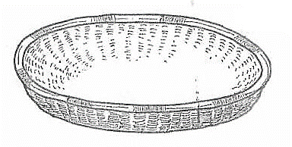

1. What is the name of the farm machinery?
   1. Gourd C. Leaf bag
   2. Winnower D. Flour sieve
2. The farm machinery is used for ….
   1. Storing relish
   2. Preserving seeds
   3. Grinding millet
   4. Separating seeds
3. Which of the following is a way of tending flowers?
   1. Drying C. Harvesting
   2. Trimming D. Selling
4. In which of the following records are the daily activities on a farm shown?
   1. Crop record
   2. Layers record
   3. Labour record
   4. Field operation record
5. Which of the following is a sign of overfeeding fish in a pond?
   1. Water changes to green
   2. Fish swimming to the bottom of the pond
   3. Small amount of food floating
   4. Dead fish seen floating
6. The principle of “substitution of inputs” helps to solve the problem of
   1. How to produce
   2. What to produce
   3. Where to sell
   4. When to sell
7. Why is it important to have box ridges?
   1. They hold water
   2. They control pest
   3. They increase soil fertility
   4. They control weeds
8. Why should some seeds be put in water first before sowing?
   1. To kill the pest
   2. To prevent the diseases
   3. To soften the seed coat for easy germination
   4. To prevent the pests from entering the seeds
9. Which of the following is a reason why a farmer should paint a wheelbarrow?
   1. To reduce friction
   2. To make it strong
   3. To prevent rusting
   4. To attract customers
10. Which of the following types of crop production does the growing?
    1. Olericulture C. Silviculture
    2. Floriculture D. Pomoculture
11. Why are farmers advised to face away from wind when spraying?
    1. To spray the chemical fast
    2. To spray more chemicals
    3. To prevent clothes from chemicals
    4. To avoid inhaling chemicals
12. Which of the following nutrients is required by plants in large quantity?
    1. Nitrogen C. Chlorine
    2. Calcium D, Copper
13. Why should farmers sell their crops when they are scarce?
    1. To prevent them from thieves
    2. To make them available to everyone
    3. To make profit
    4. To avoid hunger
14. Fish in a pond are fed at the rate of 5% of body weight daily. If the total weight of all the fish in a pond is 200kg, the amount of feed needed per day is
    1. 5kg C. 100kg
    2. 10kg D. 200kg
15. Why should a farm-cart be filled with reflectors?
    1. To avoid accidents
    2. To attract customers
    3. To scare away thieves
    4. To provide light at night
16. Which of the following ways can improve soil fertility?
    1. Practicing crop rotation
    2. Practicing monocropping
    3. Cultivating land every year
    4. Making ridges along the slope
17. Which of the following is a raw material for paper production?
    1. Cotton C. Trees
    2. Sugarcane D. Hides

**SCIENCE AND TECHNOLOGY** (20 marks)

1. Which of the following foods provide the body with energy?
   1. Fish C. Honey
   2. Pumpkin leaves D. Beans
2. Animals with jointed legs are known as …
   1. molluses C. nematodes
   2. annelida D. arthropods
3. Lack of iron the diet cause……..
   1. anaemia C. goiter
   2. scurvy D. rickets
4. Which of the following can prevent the spread of cholera?
   1. eating a balanced diet
   2. washing hands before eating
   3. draining stagnant water
   4. keeping patients in well ventilated room
5. Where does the exchange of oxygen and carbon dioxide take place in the human body?
   1. brochiole C. alveoli
   2. trachea D. nostrils
6. Which of the following crops has an erect stem?
   1. pumpkin C. sweet potato
   2. pawpaw D. banana
7. What type of force is produced as a result of rubies two objects
   1. Gravitational Force
   2. Magnetic Force
   3. Frictional force
   4. Elastic force

**Figure 2 is a diagram showing changes of state of matter. Use it to answer questions 28 and 29.**

**P**

**Solid Liquid Y**

1. What process is represented by the letter P?
   1. Melting C. Condensation
   2. Freezing D. Evaporation
2. How could the change of state of matter labelled Y be useful to human beings?
   1. drying clothes
   2. brewing beer
   3. forming ram
   4. preserving food
3. Which of the following sense organ is used for touching?
   1. nose C. tongue
   2. skin D. ear
4. Which of the following machines uses the principle of lever?
   1. pulley C. screw
   2. wedge D. spanner
5. The heart pumps blood to the lungs through …….
   1. vena cava
   2. aorta
   3. pulmonary artery
   4. pulmonary vein
6. Which of the following is a characteristic of wind pollinated flowers?
   1. have no nector
   2. have bright petals
   3. produce scent
   4. anthers are held firmly
7. Which of the following parts of a computer is used to enter information into the processor?
   1. cursor C. monitor
   2. keyboard D. mouse
8. Why is it advisable to wash fruits before eating?
   1. to improve quality
   2. to prevent germs’
   3. to improve tastes
   4. to improve flavor
9. Which of the following food combinations is a balanced diet?
   1. potatoes, bananas and meat
   2. spinach, pawpaw and rape
   3. cassava, bananas and potatoes
   4. spinach, meat and beans
10. Which of the following is a sign of marasmus?
    1. poor appetite
    2. boiled eggs
    3. stunted growth
    4. swollen body
11. Some people can became vegetarians because of …….
    1. gender C. age
    2. funeral D. religion
12. What is the purpose of carrying out scientific investigations?
    1. collecting data through experiments
    2. coming up with variables
    3. designing the experiments
    4. finding out the truth about something
13. Apart from Anaemia, what can be another effect of loosing excess blood in the body?
    1. brochiole C. alveoli
    2. death D. high blood pressure

**SECTION B**

**Structured Questions** (60 marks)

* Answer all questions in the space provided

**AGRICULTURE** (30 marks)

1. a. State any **two** ways in which agriculture is very important.

___________________________________________________________________________

___________________________________________________________________________ [2]

b. Arrange the following cross into “food crops” and “cash crops”.

***cotton, cassava, sun flower, maize***

**FOOD CROPS CASH CROPS**

__________________________ __________________________

__________________________ __________________________

__________________________ __________________________

__________________________ __________________________ [4]

1. a. Name the **two** types of forests.

___________________________________________________________________________

___________________________________________________________________________ [2]

b. Give any characteristics “**exotic trees**”

___________________________________________________________________________

___________________________________________________________________________ [2]

c. Explain any **one** way in which trees reduce soil erosion.

___________________________________________________________________________

___________________________________________________________________________ [2]

1. a. List any **two** activities involved when preparing land for growing fruits.

___________________________________________________________________________

___________________________________________________________________________ [2]

b. Name the types of irrigation suitable for each of the following.

* + 1. rice

________________________________________________________________________ [1]

* + 1. fruit tree

________________________________________________________________________ [1]

c. Give a reason why watering of seedlings before transplanting is important.

___________________________________________________________________________

___________________________________________________________________________ [1]

1. **Figure 3 is a diagram of a method of managing a woodlot. Use it to answer questions that follow**

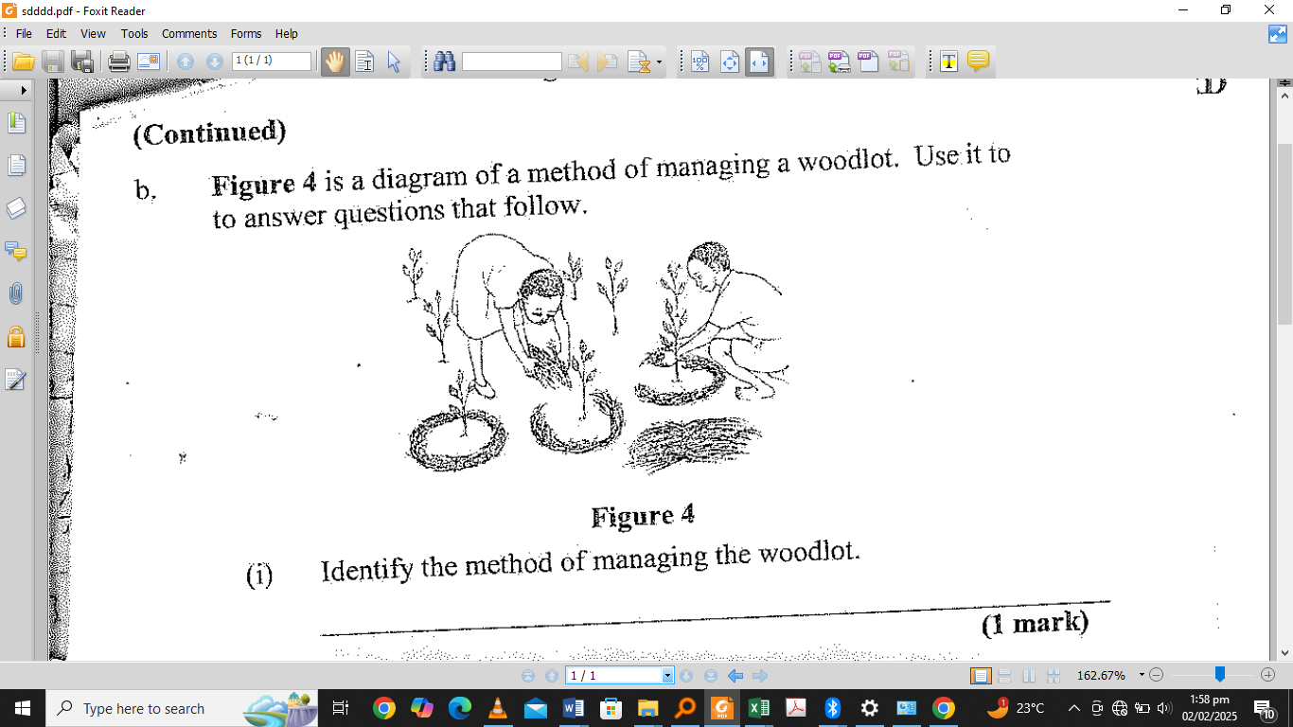

a. Identify the method of managing the woodlot.

___________________________________________________________________________

___________________________________________________________________________ [1]

b. Give any **two** reasons why the method of managing the woodlot is important.

___________________________________________________________________________

___________________________________________________________________________

___________________________________________________________________________

___________________________________________________________________________ [2]

1. a. State any **two** characteristics of commercial farming.

___________________________________________________________________________

___________________________________________________________________________

___________________________________________________________________________

___________________________________________________________________________ [2]

b. Give any **two** examples of capital items on a farm.

___________________________________________________________________________

___________________________________________________________________________ [2]

1. a. Name any **two** feeding habits of goats.

___________________________________________________________________________

___________________________________________________________________________ [2]

b. State **two** characteristics of goats suitable for breeding.

___________________________________________________________________________

___________________________________________________________________________ [2]

c. Give **two** factors to be considered when designing a fish pond.

___________________________________________________________________________

___________________________________________________________________________ [2]

**SCIENCE AND TECHNOLOGY** (30 marks)

1. a. List any **three** foods suitable for old people.

________________________________________________________________________

________________________________________________________________________

________________________________________________________________________ [3]

b. Give any **two** factors to consider when planning meals for old people.

________________________________________________________________________

________________________________________________________________________ [2]

c. State any **one** function of leaves in plants.

________________________________________________________________________ [2]

1. Construct a food chain for the following living things; ***birds, grass, people and grasshopper***.

[3]

1. **Figure 4 is a diagram showing longitudinal section of the human heart.**

**Use it to answer the questions that follows:**

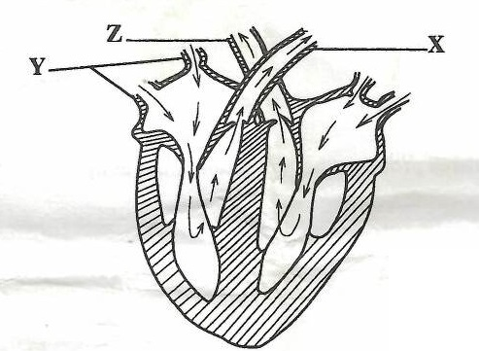

a. Name the part labelled **X**.

________________________________________________________________________ [1]

b. State the function of the part labelled **Z**.

________________________________________________________________________ [2]

c. Explain the effect on a human being if the heart stopped pumping blood.

________________________________________________________________________

________________________________________________________________________

________________________________________________________________________ [3]

1. a. Give any **two** cultural practices that can lead to the spread of HIV.

________________________________________________________________________

________________________________________________________________________ [2]

b. Explain **one** way in which HIV and AIDS has affected the provision of health services in Malawi

________________________________________________________________________

________________________________________________________________________ [2]

1. State **one** way of separating each of the following mixtures.
   1. Solutions.

_______________________________________________________________________

_______________________________________________________________________ [1]

* 1. Rice and iron particles

_______________________________________________________________________

_______________________________________________________________________ [1]

1. Explain the advantage of dissolving sugar in hot water.

__________________________________________________________________________

__________________________________________________________________________

__________________________________________________________________________

__________________________________________________________________________ [2]

1. a. Draw an electric circuit with two cells a switch and two bulbs in series.

[4]

b. Name any **two** groups of vertebrate animals.

________________________________________________________________________

________________________________________________________________________ [2]

`End of question paper